

**JOMO KENYATTA UNIVERSITY OF AGRICULTURE AND**

**TECHNOLOGY**

***Information Technology Department***

P O Box 62000, Nairobi, KENYA. Telephone: 067-52252/3/4, 067-52711 extn 8067

Fax: 067-52254

**PROJECT**

**AI POWERED PERSONAL FINANCE ASSISTANT SYSTEM**

**NAME: BRIAN KIPRONO**

**REGNO: SCT221-C004-0029/2022**

This project is submitted to Jomo Kenyatta University of Agriculture and technology in the

Partial fulfilment of Bachelor in Information and Technology in the year 2025

# Declaration

This presentation is original in every aspect and is being presented for the first time in Jomo

Kenyatta University of Agriculture and Technology is unique.

SIGNATURE: BK DATE: 11/06/2025

STUDENT……BRIAN KIPRONO…………………………………………………....

This proposal is submitted with my approval as University Supervisor.

SUPERVISOR…………………………. ……………………………….

# Acknowledgement

I acknowledge with great honour the effort of the following people in the successful research

and completion of the Campus Guide system; The Almighty God for the strength and ability

to successfully got through this huddle, My parents, friends and finally websites for the tips

and guidance through understanding the functionality ofAi Powered Personal Finance Assistant System

# Dedication

I would like to dedicate this AI-powered Personal Finance System to individuals and businesses striving to manage their finances effectively. This system aims to assist in making informed financial decisions, streamlining budgeting, and empowering users to achieve financial stability and success.

Contents

Declaration ii

Acknowledgement iii

Dedication iv

Abstract viii

CHAPTER ONE 1

Introduction 1

1.0 Introduction 1

1.1 Background Study 2

1.2 Problem Statement 3

1. 3 Research Questions 3

1.4 Objective of Study 4

1.4.1 General Objective 4

1.4.2 Specific Objectives 4

1.5 Justification 4

1.6 Proposed Research and System Methodology 5

1.6.1 Research Methodologies 5

1.6.2 System Methodology 6

1.7.1 limitation of the Project 7

1.7.2 Assumptions 7

1.8 Requirements 8

1.8.1 Hardware Requirements 8

1.8.2 Software Requirements 8

CHAPTER TWO 9

Literature Review 9

2.0 Introduction 9

2.1 Theoretical Review 11

2.2 Web-based Financial Applications 11

2.3 Personal Budgeting Research 13

2.4 Financial Literacy Initiatives 15

2.5 Financial Literacy and Investing 16

2.6 AI Applications in Finance 17

2.7 Intelligent Finance Assistants 20

CHAPTER THREE 21

Methodology 21

3.0 Introduction 21

3.1 Used Methodology 22

3.2 Research design 23

3.2.0 Qualitative Design 23

3.2.1 Quantitative Design 23

3.2.2 Prototype Testing 23

3.2.3 Iterative Development and Refinement 24

3.3 Participants or sample 24

3.3.0 Target Audience 24

3.3.1 Sample size 25

3.3.2 Recruitment criteria 25

3.4 Data collection 25

3.4.0 Qualitative Methods 25

3.4.1 Quantitative Methods 27

3.5 Technical Data 30

3.5.0 AI Model Performance 30

3.5.1 User Interaction Data 30

3.5.2 Security and Privacy Data 31

3.5.3 Financial Data Processing 31

3.5.4 System Compatibility and Integration 31

3.5.5 Error and Bug Tracking 31

3.5.6 Resource Usage 31

3.6 Data analysis 32

3.6.0 Qualitative Data Analysis 32

3.6.1 Quantitative Data Analysis 32

3.6.2 Ai models insight 33

3.6.3 Integration of findings 34

3.7 Ethical considerations and Data Security 35

3.7.1 Ethical AI Practices 36

3.7.2 Privacy Considerations 36

3.7.3 Ethical Challenges and Mitigations 37

3.7.4 Ongoing Ethical Governance 37

3.8 Data Presentation 38

CHAPTER FOUR 39

System Analysis and Requirement 39

4.0 Introduction 39

4.1 Analysis of the Current System 39

4.2 Feasibility Analysis 39

4.3 Economic Analysis 40

4.4 Technical Analysis 40

4. 5 Operational Analysis 40

4.6 The Proposed system 41

4.6.1. Functional requirements 41

4.7 Non-functional requirements 41

4.8 System specifications 43

4.9 Security Requirements 43

4.10 Feasibility 44

Operational Feasibility 44

Technical Feasibility 44

CHAPTER FIVE 46

5.0 System Design 46

5.0.1 Conceptual Design 48

5.0.2 Logical design 50

5.1 Use Case modelling 55

4.4.2. Sequence diagram 56

4.4.3. Activity Diagram 58

CHAPTER SIX 61

6.1 Introduction 61

6.2 Interface Implementation 61

6.2.1 System Interface Coding tools 61

6.4 Testing 61

6.4.1 Unit Testing 61

6.4.2 Module Testing 61

6.4.3 Validation Testing 62

6.4.4 System Testing 62

6.4.2 Security Testing 62

Security component 62

6.5 System Review and Maintenance 62

CHAPTER SEVEN 63

7.0 Conclusion and Future scopes 63

7.1 Future Scope 63

APPENDIX 64

Reference 66

# Abstract

Managing finances can be daunting due to the complex financial landscape, lack of financial literacy and difficulty tracking expenses or budgeting. Existing tools often need more personalization, rely on static budgeting, and provide generic investment advice. To address these limitations and enhance financial literacy and management, this paper proposes the development of an AI-powered personal finance assistant. The proposed assistant will utilize machine learning and natural language

processing to provide a comprehensive financial overview, personalized insights and recommendations, and educational content tailored to users’ needs. Key features include automated expense tracking, customized budgeting aligned with income and spending patterns, tailored investment advice based on risk appetite and goals, and proactive notifications about significant financial events. The methodology involves leveraging a robust technology stack (React.js, Flask, MongoDB, Firebase) to enable these features. Qualitative and quantitative evaluations will be conducted to ensure the assistant’s effectiveness, ease of use, and utility, including focus groups, usability assessments, and longitudinal studies across diverse demographics. Specific metrics for evaluation will include improvements in financial literacy measured by pre-and post-use tests, quality of financial decision-making, user satisfaction scores, task completion rates, feature utilization, and

user engagement levels. The expected outcomes include improved financial acumen, optimal financial decision-making, achievement of monetary goals, and secured financial futures for users.

Extensive literature review and preliminary prototyping validate the proposed solution’s potential

to address current limitations in personal finance tools. The assistant will incorporate robust data

encryption, personalized educational content, and design considerations around user contexts to

address security and generalizability concerns. By delivering a secure, intelligent, and comprehensive

platform, the assistant aims to empower users to manage all aspects of their finances effectively,

ultimately transforming financial literacy and management practices.

Keywords:

Artificial Intelligence, Personal Finance, Financial Literacy, Financial Management

# 

# CHAPTER ONE

# Introduction

### Introduction

Managing personal finances is becoming increasingly challenging due to financial landscape complexities, lack of financial literacy, and difficulties tracking expenses or creating effective budgets. Conventional finance tools lack personalization, rely on static budgeting, and provide generic investment advice. This paper proposes developing an AI-powered personal finance assistant to address these limitations. The assistant will provide a comprehensive financial overview, personalized insights using machine learning, and educational content to enhance financial literacy. By automating expense tracking, creating adaptive budgets, offering tailored investment recommendations, and providing proactive notifications, the proposed assistant aims to transform financial management

An AI-powered personal finance assistant system can revolutionize personal financial management by providing a smarter, automated approach to tracking expenses, managing budgets, and making informed financial decisions. By integrating with users' financial accounts, the system continuously monitors transactions, categorizes spending, and identifies patterns. This allows for real-time insights, dynamic budget adjustments, and personalized financial recommendations that go beyond traditional budgeting methods. Key features include automated expense tracking, personalized budgeting, goal-based savings plans, and tailored investment suggestions. The AI assistant can also forecast future spending, alert users to overspending or upcoming bill payments, and provide suggestions to optimize savings or debt repayment. With these capabilities, users gain better financial awareness, save time through automation, and potentially save money through smarter spending decisions. Security is paramount, with strong encryption and privacy measures in place to protect sensitive financial data. As the system evolves, it could incorporate financial education modules, social features, or even advanced technologies like blockchain, making personal financial management more intuitive, personalized, and goal-oriented. Ultimately, such a system empowers users to build healthier financial habits, achieve financial goals, and improve their overall financial well-being.

### 

### 1.1 Background Study

AI personal finance assistant systems have emerged as a significant innovation in personal financial management, driven by advancements in artificial intelligence (AI), machine learning (ML), and natural language processing (NLP). These systems help users manage their finances by providing personalized advice on budgeting, expense tracking, savings, investments, and debt management. Traditionally, financial advisory services were managed by human advisors, but AI systems now offer real-time, data-driven insights that simplify financial decision-making. AI personal finance assistants use ML algorithms to analyse user data, such as spending habits, income, and financial goals, to deliver tailored recommendations. Natural language processing (NLP) enables these systems to understand and respond to user queries conversationally, making them more accessible and user-friendly.

Key applications include tracking expenses, forecasting savings, managing investments, and assisting with debt repayment strategies. Companies like Mint, Cleo, and rob-advisors like Betterment leverage AI to automate and optimize these tasks, providing users with a convenient, low-cost solution. Despite these advantages, challenges remain. Data privacy and security are major concerns, given the sensitive nature of financial data. Additionally, ethical issues, such as biases in algorithmic decision-making and lack of transparency, could impact user trust and adoption. Accuracy of AI predictions, especially in unpredictable financial markets, is another limitation that users need to be aware of. Looking ahead, future trends point to deeper integration with voice assistants, wearables, and IoT devices, offering real-time financial monitoring and more accurate predictive analytics.

AI-powered personal finance assistants promise to revolutionize personal finance management by offering convenience, personalization, and improved decision-making. However, challenges such as privacy, ethical considerations, and user trust must be addressed to fully unlock their potential in helping users achieve financial well-being.

### 1.2 Problem Statement

Managing personal finances effectively is a challenge for many individuals due to various factors such as lack of financial knowledge, difficulty tracking expenses, and the complexity of financial planning. Traditional budgeting methods and manual tracking often fail to provide real-time insights, personalized recommendations, or guidance that can help users make informed financial decisions. This leads to overspending, missed savings opportunities, and suboptimal investments, which can have long-term financial repercussions. An AI-powered personal finance assistant system can address these challenges by providing users with an intelligent and automated solution that helps track expenses, manage budgets, and make smarter financial decisions. The system would integrate with users' financial accounts, analyse their spending habits, and provide personalized insights, recommendations, and alerts to improve their financial well-being

### 1. 3 Research Questions

(i) How do AI-powered personal financial systems influence individual financial decision-making, particularly in terms of saving, investing, and budgeting behaviours?

(ii) What are the accuracy and reliability of AI-driven personal financial management tools compared to traditional financial advisory services?

(iii) What factors affect user trust and adoption of AI-powered personal financial systems, and how does trust influence user engagement?

(iv) What are the security and privacy risks associated with AI-driven personal financial management tools, and how can these risks be mitigated?

(v) To what extent do AI-powered financial systems provide personalized financial advice, and how does personalization affect user satisfaction and financial outcomes?

(vi)How do AI algorithms in personal financial management systems address issues of bias and fairness, particularly with respect to underserved populations?

## 1.4 Objective of Study

### 1.4.1 General Objective

The general objective of this study is to explore the impact, capabilities, and challenges of AI-powered personal financial systems in improving individual financial management, decision-making, and long-term financial well-being.

### 1.4.2 Specific Objectives

(i) To analyse the influence of AI-powered personal financial systems on users’ financial decision-making, particularly in the areas of saving, investing, and budgeting.

(ii) To evaluate the accuracy, reliability, and effectiveness of AI-driven financial tools compared to traditional financial advisory services.

(iii) To investigate user trust and adoption of AI-based financial systems, and the factors influencing continued use and engagement with these technologies.

(iv)To assess the risks related to data privacy and security when using AI-powered personal finance tools, and identify possible mitigation strategies.

(v) To examine the role of personalization in AI-powered financial systems and its effect on user satisfaction and financial outcomes.

(vi) To explore the potential biases and ethical implications of using AI in personal financial management, especially concerning marginalized or underserved populations.

### 1.5 Justification

AI-powered personal financial systems are becoming increasingly prevalent, offering users tools for budgeting, saving, investing, and managing debt with little human intervention. These systems have the potential to significantly improve financial literacy and well-being by providing personalized and data-driven recommendations. However, the reliance on AI raises several questions about accuracy, trustworthiness, ethical concerns, and data security

# 1.6 Proposed Research and System Methodology

The proposed research aims to develop an AI-powered finance assistant system designed to optimize

personal financial management by leveraging advanced AI techniques such as machine learning,

natural language processing (NLP), and predictive analytics. The system will integrate with various

financial platforms to provide real-time data synchronization and offer personalized advice on

budgeting, spending, investments, and goal-setting. By analysing user behaviour, financial trends, and

external economic factors, the system will provide tailored insights and recommendations to help

users make informed decisions. Additionally, the assistant will feature user-friendly interfaces and

secure data processing, ensuring both ease of use and privacy. The goal of this research is to create

an intelligent, responsive assistant that not only simplifies financial tasks but also empowers users to

improve their financial health and achieve long-term financial goals

## 1.6.1 Research Methodologies

In the development of an AI-powered finance assistant system, a variety of data collection methods

will be utilized to ensure the system is both effective and personalized. Surveys and questionnaires

will capture qualitative insights from users about their financial habits and goals, while transaction

data from financial platforms will be integrated to track spending, income, and savings patterns. User

interaction logs will help analyse how users engage with the assistant, providing valuable feedback

on system usage and preferences. Additionally, external financial data, such as market trends and

economic indicators, will be used to enhance the system's predictions and recommendations.

Interviews and focus groups will gather in-depth qualitative insights to better understand user needs,

while experimental data will help refine the system's performance. Publicly available datasets will aid

in training machine learning models, and continuous user feedback will guide ongoing

improvements. By combining these diverse data collection methods, the system can be tailored to

individual financial needs, improving both user experience and financial decision-making outcomes.

## 1.6.2 System Methodology

The system methodology for developing an AI-powered finance assistant system follows a structured

approach to ensure the platform delivers personalized, secure, and efficient financial management. It

begins with requirement gathering through surveys and interviews to understand user needs,

followed by data collection from diverse financial sources like transaction data, market trends, and

economic indicators. The system is then designed with a modular architecture that integrates data

sources, AI models for predictive analysis, and an intuitive user interface. Machine learning, natural

language processing, and reinforcement learning techniques are used to build intelligent features like

personalized budgeting, investment advice, and real-time financial insights. The system is tested for

accuracy, security, and usability through rigorous testing phases, ensuring robust performance. Once

deployed, the system is continuously improved based on user feedback and evolving financial data.

The methodology prioritizes secure data integration, user-centric design, and continuous learning to

provide users with a reliable and dynamic finance assistant.

**1.7 Scope of Studies**

The scope of this study is centred on examining the impact of AI-powered personal financial systems on individual financial management. It covers several key areas, including the technological frameworks of AI, with a focus on machine learning and data analytics tools used in financial systems. The study also explores the user demographics that engage with these technologies, emphasizing individual users rather than businesses or institutions, and investigates common functions such as budgeting, investment, debt management, and retirement planning. A comparative analysis will be conducted between AI-powered financial tools and traditional financial advisory services to assess effectiveness and reliability. Geographically, the research will focus primarily on regions where AI-powered financial systems are widely adopted, such as the U.S., Europe, and parts of Asia. Additionally, the study will delve into security and ethical concerns related to data privacy, algorithmic transparency, and potential biases affecting underserved populations.

### 1.7.1 limitation of the Project

This project faces several challenges that could affect its outcomes. Time constraints may limit the depth of the analysis, particularly regarding the long-term impact of AI on financial well-being. The complexity of AI technology and the proprietary nature of some systems may limit the study's ability to fully understand or assess these models. User behaviour, which varies greatly among individuals, may limit the generalizability of findings, especially for users less familiar with AI technology. Additionally, financial institutions may restrict access to key insights about their AI models, hindering a thorough evaluation. Cultural and socioeconomic factors, as well as differences in regulatory frameworks across regions, may further complicate the generalization of results, making it difficult to apply findings across different contexts globally.

## 1.7.2 Assumptions

The AI-powered finance assistant system assumes several key factors for successful development and

implementation. First, it assumes that users will have access to their financial data through

integrations with banks and other financial institutions, enabling real-time tracking and analysis of

transactions. It also assumes a basic level of financial literacy from users, allowing them to engage

effectively with the assistant’s recommendations. The system relies on the accuracy and integrity of

the data provided, ensuring that predictions and advice are based on reliable information.

Additionally, it assumes that users will actively participate by providing input on their financial goals

and preferences, enabling the system to offer personalized insights. Security and privacy are also

assumed, with robust measures in place to protect sensitive financial information in compliance with

regulations. Finally, the system assumes that technological infrastructure, including cloud services

and APIs, will remain reliable and scalable, ensuring smooth operation and integration with external

platforms. These assumptions will help shape the system's design, functionality, and user experience.

# 1.8 Requirements

## 1.8.1 Hardware Requirements

The hardware requirements for the AI-powered finance assistant system are designed to ensure

efficient development, deployment, and performance. During the development phase, high-

performance workstations with multi-core processors, ample RAM, and dedicated GPUs are essential

for building and testing machine learning models. For cloud deployment, scalable servers with

powerful CPUs, large storage capacity, and high-bandwidth networking are necessary to handle real-

time data processing, user traffic, and financial data integration. Specialized hardware such as GPUs

or TPUs may be required for training complex AI models, while cloud-based storage solutions offer

secure and scalable data management. Additionally, user devices such as smartphones, tablets, and

desktops must support seamless interaction with the system through intuitive interfaces. Backup and

redundancy hardware ensures data security and system reliability, providing a robust infrastructure

for the system's continuous operation and growth.

## 1.8.2 Software Requirements

The software requirements for the AI-powered finance assistant system are essential for ensuring the

platform’s functionality, security, and scalability. Development tools such as Python for machine

learning, JavaScript for web and mobile apps, and SQL/NoSQL databases for data management are

crucial for building and running the system. AI frameworks like TensorFlow and scikit-learn enable

the system to provide personalized financial recommendations, while natural language processing

tools like spaCy and Dialogflow facilitate user interaction through chatbots. The backend relies on

web frameworks like Django and cloud services (AWS, Google Cloud) for hosting and scaling. Front-

end frameworks such as React.js and mobile development platforms like React Native ensure a

seamless, cross-platform user experience. Security is prioritized with SSL/TLS encryption, JWT for

secure authentication, and tools for regular testing and load handling to guarantee system reliability.

Together, these software components support real-time data processing, secure transactions, and a

smooth user interface, allowing the finance assistant to offer tailored financial guidance and advice

# CHAPTER TWO

## Literature Review

### 2.0 Introduction

The integration of artificial intelligence (AI) capabilities in personal finance management has garnered increasing research attention, accentuating technology’s potential in addressing intricacies in financial processes and decision contexts faced by individuals. This literature review analyses scholarship on the application of web-based tools, responsive systems, AI techniques, financial literacy initiatives and intelligent assistants to inform the development of an AI powered personalized finance solution

showed that advanced methods supplemented rather than substituted traditional techniques. Waliszewski and Warchlewska specifically explored consumer AI finance tool acceptance, finding demographic variations. User studies remain vital for successful AI financial solution implementation

In today’s fast-paced digital economy, effective personal finance management has become essential for individuals seeking to achieve financial stability and long-term goals. With rising costs of living, increasing debt levels, and complex financial products, individuals often face challenges in managing their finances efficiently. Traditionally, personal finance management has relied on manual budgeting methods, financial advisors, and paper-based tools. However, the advent of technology has transformed this landscape, offering innovative solutions that leverage data analytics and automation to enhance financial decision-making. Artificial Intelligence (AI) has emerged as a game-changing technology in the realm of personal finance, providing users with personalized, actionable insights that were previously unattainable through conventional methods. AI-powered personal finance assistants utilize advanced algorithms and machine learning techniques to analyze vast amounts of financial data, enabling them to provide tailored advice, track spending patterns, and predict future financial behaviors. These systems can engage users through natural language processing (NLP), allowing for more intuitive interactions and real-time guidance. The integration of AI into personal finance not only enhances the user experience but also promotes financial literacy and accessibility. By simplifying complex financial concepts and offering targeted recommendations, AI tools can empower users to make informed decisions about their finances. Additionally, these technologies are increasingly accessible, catering to a diverse range of users, from tech-savvy millennials to those less familiar with digital financial tools. Despite the numerous benefits, the deployment of AI in personal finance raises critical questions about security, privacy, and user trust. The handling of sensitive financial information by AI systems necessitates robust security measures and clear data usage policies to mitigate risks associated with data breaches and unauthorized access. Furthermore, understanding user perceptions and trust in AI-generated advice is crucial for widespread adoption.

This literature review aims to explore the current state of AI-powered personal finance system assistants, examining their technological foundations, user interactions, implications for financial behavior, and the challenges they present. By synthesizing existing research and identifying key themes, this review will provide insights into how AI is shaping the future of personal finance management and highlight areas for further exploration in this rapidly evolving field

Personal finance management involves the processes individuals use to effectively manage their financial resources, encompassing key components such as budgeting, saving, investing, debt management, and retirement planning. Despite its importance, many face challenges like a lack of financial literacy, behavioural biases that hinder optimal decision-making, and time constraints that prevent effective management. Additionally, socioeconomic factors can create barriers to accessing essential financial resources. However, the advent of technology has transformed personal finance, with a range of digital tools and applications designed to assist users in tracking spending and achieving financial goals. AI-powered personal finance assistants, in particular, leverage machine learning and data analytics to provide personalized insights, enhancing user engagement and simplifying financial management. As technology continues to evolve, addressing the challenges associated with personal finance remains crucial for empowering individuals to achieve financial stability and success.

The rise of artificial intelligence (AI) in personal finance signifies a transformative shift in how individuals manage their financial resources. Fuelled by advancements in machine learning and natural language processing, AI technologies enable the creation of personalized and automated financial tools that enhance user engagement and decision-making. AI-powered personal finance assistants analyse vast amounts of financial data to deliver tailored recommendations, automate budgeting, and provide real-time insights into spending and investing behaviours. These systems not only simplify complex financial concepts but also promote financial literacy by educating users on best practices. However, the growing reliance on AI in personal finance raises important concerns regarding data privacy, security, and algorithmic bias, necessitating careful consideration to build user trust and ensure equitable access to financial advice. As AI continues to evolve, it has the potential to democratize financial management, empowering individuals to achieve their financial goals more effectively and confidently

# 2.1 Theoretical Review

The evolution of AI-powered personal finance systems has transformed how individuals manage their financial lives, moving from simple automation to highly personalized, predictive tools. In the early stages, systems focused on basic budgeting and expense tracking, such as Mint or Quicken. The introduction of robo-advisors in the 2010s marked a significant shift, automating investment management and making financial advice more accessible. As machine learning and big data became more advanced, these systems could offer personalized recommendations, optimize spending, and predict future financial behaviour. By the late 2010s, natural language processing enabled more intuitive, interactive experiences through AI-driven chatbots like Erica and Cleo. In the 2020s, AI-powered systems integrated across broader financial ecosystems, utilizing open banking to provide a more comprehensive view of a user’s finances and offering dynamic, real-time advice. Moving forward, AI is expected to expand financial

inclusion, improve credit access, and drive innovations in decentralized finance, making personal finance management even more accessible and tailored to individual needs.

AI-powered personal finance systems are revolutionizing the way individuals manage their financial lives by providing personalized, data-driven insights and automating complex tasks. These systems leverage machine learning algorithms, natural language processing, and big data analytics to track spending habits, optimize investments, and provide real-time financial advice. The ability to personalize budgeting, investment strategies, and financial goal setting offers significant advantages, such as increased efficiency, accessibility, and better decision-making. However, challenges such as data privacy concerns, the lack of transparency in decision-making, and potential biases in algorithmic models must be addressed. As AI technology continues to evolve, it has the potential to democratize financial management, making it more accessible and tailored to individual needs while improving financial literacy and decision-making capabilities.

## 2.2 Web-based Financial Applications

Web-based platforms offer automation capabilities to streamline financial workflows. Sari et al. developed an online application using PHP and MySQL for a boarding house in Indonesia to integrate planning, budgeting, auditing and billing. At the same time, they were overcoming limitations in manual bookkeeping, usability assess Web-based Financial Applications Web-based platforms offer automation capabilities to streamline financial workflows. Sari et al. developed an online application using PHP and MySQL for a boarding house in Indonesia to integrate planning, budgeting, auditing and billing. At the same time, they were overcoming limitations in manual bookkeeping, usability assessments, security and comparisons with existing solutions that needed to be improved. Ahmed et al. presented a responsive university budget management system for Iraq using HTML, PHP, JavaScript and AJAX. High user satisfaction was reported, but evaluations of adaptability and long-term impacts were omitted. Overall, web-based finance tools enable process improvements but require holistic solutions factoring in human perspectives, security and comparisons with existing solutions that need to be improved. Ahmed et al. presented a responsive university budget management system for Iraq using HTML, PHP, JavaScript and AJAX. High user satisfaction was reported, but evaluations of adaptability and long-term impacts were omitted. Overall, web-based finance tools enable process improvements but require holistic solutions factoring in human perspective

Web based applications are the ultimate way to take advantage of today's technology to enhance the organization's productivity and efficiency. The finance system allows transferring the financial matters between savers and borrowers. An organization can operate on a global, regional or firm specific level. Financial services and systems can also be described as comprising a set of complex and closely interconnected financial institutions, markets, instruments, services, practices, and transactions. A software development is in view of the public, which means that anyone has access to the source code and can change, improve, test, and use it. Open-source projects such as Firefox or the ERP Business Suite have produced high-quality results, indicating that bazaar-like software engineering models are effective. Commercial financial systems are highly expensive to implement. Educational ERP has a wide area of application and nowadays educational institutes are also looking for ERP implementation where finance is a mandatory module. The OS business model, based on a contribution of a large number of individuals and partners, definitely affects the framework quality and rapid growth of the platform capabilities. A survey was conducted showing that even within the 500 largest Polish companies only 50 % have an ERP-system, which in comparison with Western European companies is far less; for example, in Germany 95 % of the companies with more than 500 employees have an ERP-System.

A web based financial application gives an opportunity to access the business information from anywhere and anytime all over the world. It also facilitates saving time, money and improves the interactivity with other customers and partners. The web-based applications are easy to use and to implement without any interrupt with the existing work process. It needs a content managed solution or an e-commerce system. It is developed as a customized web application that fulfils the business requirements. The same web-based software can provide multimedia support to the end user. The developed web application is accessible from mobile phone and personal computer at the same time. There are many applications that can be accessible from mobile and personal computers but the difference is that it is the financial system, which is accessing a database having huge data and many stored procedures, a lot of triggering etc. A web-based system has database server and browser interface integrated by web server

## 2.3 Personal Budgeting Research

Personal budgeting is an integral yet complex financial process. Galperti examined theoretical links between budgeting and consumption-saving biases, showcasing associated self-control issues. However, consistency in real-world budget adherence and tracking efforts necessitate further investigation. Specific budgeting approaches also vary with individual biases and trade-off perceptions. Additional research on overcoming budgeting difficulties could elevate financial outcomes.

Prominent research argues that consumers often use personal budgets to manage self-control problems. This paper analyses the link between budgeting and self-control problems in consumption–saving decisions. It shows that the use of good specific budgets depends on the combination of a demand for commitment and the demand for flexibility resulting from uncertainty about intertemporal trade-offs between goods. It explains the subtle mechanism that renders budgets useful commitments, their interaction with minimum-savings rules (another widely studied form of commitment), and how budgeting depends on the intensity of self-control problems. This theory matches several empirical findings on personal budgeting.

Many studies argue that personal budgeting is a pervasive part of consumer behaviour. This practice involves grouping expenses into categories and constraining each with an implicit or explicit cap applied to a specified time period (a week, a month, etc.). While this practice cannot be explained by the classic life-cycle theory of the consumer, it has important consequences. It can account for “mysterious” large differences in wealth accumulation between consumers that time or risk preferences cannot explain

This paper uses the term “personal budgeting” rather than “mental accounting” because the latter has the much broader meaning of a general process whereby people frame events, outcomes, and decisions. This also includes choice bracketing, narrow framing, and gain–loss utility, which differ from budgeting

By violating the principle of fungibility of money, it shapes demand differently from satiation and income effects (Heath and Soll 1996). It affects how firms promote their products so as to avoid competing for the same budget (Wertenbroch 2002). It is at the foundation of the economics of commitment devices (Bryan et al. 2010). Almost all existing studies informally suggest that consumers use budgets to manage self-control problems, often caused by present bias, which interfere with their saving goals (Thaler 1999, Ameriks et al. 2003, Antonides et al. 2011). Despite this consensus, a formal investigation of the link between budgeting and self-control problems seems to be missing. The paper offers such a foundation using a broadly studied aspect of time preferences: present bias. It shows, however, that present bias alone cannot explain budgeting. Present-biased consumers value constraints on future choices. But for budgets to emerge, this preference for commitment has to be combined with a preference for flexibility of a precise but plausible kind, namely that caused by uncertainty about intertemporal trade-offs due, for instance, to good-specific taste shocks. The paper also uncovers a tension between good-specific budgets and minimum-savings rules, an often-studied form of commitment. This leads to a negative relationship between the level of present bias and the use of budgets. These predictions help organize the evidence on budgeting and can guide future empirical studies.

Existing explanations of personal budgeting are based on Thaler (1985). Using the notions of “transaction utility” and gain–loss utility, he argues that agents treat the consequences of each transaction in isolation. Given this, they can solve their consumption– savings problems by means of transaction-specific budgets, a result that echoes Strotz (1957). In reality, people set budgets for sufficiently long periods so that each covers many transactions. Also, in Thaler’s deterministic model, the agents can achieve the same utility with and without budgets, but with uncertainty, they would never set binding budgets. Therefore, they do not exhibit a strict demand for budgets as commitment devices. Finally, transaction and gain–loss utility differ conceptually from self-control problems, which the literature views as the main cause of budgeting. Gain–loss utility can explain other phenomena of mental accounting, such as choice bracketing (Koch and Nafziger 2016), which, however, differs from budgeting. Other papers in the mechanism-design literature study the trade-offs between commitment and flexibility, usually imposing no restriction on the feasible mechanisms. Papers by Amador et al. (2006) and Halac and Yared (2014) are the closest to the present paper.9 We borrow their baseline model, but add multiple consumption goods and uncertainty about intertemporal trade-offs. In so doing, we show how this uncertainty affects the commitment–flexibility trade-off and its solutions. Another difference is that Halac and Yared (2014) focus on the role of information persistence. In their setting, an optimal commitment plan can distort future choices, even though they cause no conflict between the agent’s selves given today’s choice. Persistence links self-1’s current information and expected utility from future choices, which can be used to relax today’s incentive constraints, as in other dynamic mechanism-design problems.10 Correlation among self-1’s pieces of information is not the driver of the present paper’s results. An older literature examined how rationing affects consumer behaviour (Howard 1977, Ellis and Naughton 1990, Madden 1991). By setting a savings floor or good-specific budgets, an agent essentially rations his future selves just as the government may ration consumers. In contrast to that literature, here rationing assumes the role of a commitment device. That literature shows that predicting the budgets’ effects is far from trivial. Its insights are useful to identify conditions under which budgets can help the agent.

## 2.4 Financial Literacy Initiatives

With financial systems growing more sophisticated, improved financial literacy is imperative for decision-making. Molina-Garc´ıa et al. revealed negative associations between literacy and risk tolerance in university students, advocating educational interventions. Rath and Patra emphasized literacy for navigating Indian financial systems. Mireku et al. found that literacy predicts prudent student conduct in Ghana, urging literacy drives.

Recent studies have shown the positive impact of financial literacy programs on various aspects of personal financial planning and decision-making. For example, Harjito et al. (2021) found that financial education programs can enhance individuals' risk literacy and reduce their biases in investment decisions. Murad et al. (2021) argued that financial literacy is a crucial component of sustainable and inclusive urban development and can empower individuals to participate in the formal financial system and access credit and insurance.

Despite the growing evidence and interest in financial literacy programs, there are still gaps and limitations in the literature and practice of financial literacy education. Therefore, this study aims to contribute to the knowledge and understanding of financial literacy programs and their influence on personal financial planning and decision-making.

Financial literacy is defined as the ability to understand and apply financial concepts and skills to manage financial resources effectively for lifetime financial well-being (OECD, 2020). Financial literacy programs are interventions that aim to improve individuals' financial literacy through various methods and channels, such as workshops, online courses, and counselling. Personal financial planning is the process of setting financial goals, analysing the current financial situation, and developing and implementing a plan to achieve the goals (CFP Board, 2021).

Financial literacy is a critical skill that enables individuals to make informed and effective financial decisions. It involves an understanding of financial concepts and principles, as well as the ability to apply this knowledge in real-world situations. According to a report by the Organisation for Economic Co-operation and Development (OECD), financial literacy is essential for individuals to achieve financial well-being and security (OECD, 2020).

Research has shown that individuals with higher levels of financial literacy are more likely to engage in positive financial behaviours, such as saving and investing, and are less likely to experience financial difficulties, such as debt and bankruptcy (Hastings & Tejeda-Ashton, 2018). Moreover, financial literacy has been linked to a range of positive social and economic outcomes, including improved health and well-being, increased educational attainment, and reduced poverty and inequality (Sherraden et al., 2015).

## 2.5 Financial Literacy and Investing

Beyond general money decisions, financial literacy shapes investment choices. Shaheen et al. investigated factors impacting individual investors, including market dynamics. Financial literacy emerged as key for informed investments, but small samples warrant caution. Nonetheless, knowledge helps critically evaluate risks against returns. Further qualitative insights could illuminate investment decision-making processes.

The world economy has become more complex and thus, every individual needs to be active and smart in investment decisions in order to manage the rising cost of living. Many individuals are interested in one investment or the other, they view investments to be fascinating because they make decisions and later see the outcomes of the decisions they make (Awais, Laber, Rasheed & Khursheed, 2016). So virtually everybody partakes in one form of investment or the other, even those that do not partake in buying and selling of specific financial assets such as stock, they still undertake investments through participation in employee saving programme and pension plan or through purchase of life insurance or by some other kinds of investments such as real estate investments and through depositing of cash in fixed savings accounts of banks (Musundi, 2014). However, not all investments lead to profit, as investors will not always be right in their investment decisions (Natalie, 2010; Obamuyi, 2013). Baker and Nofsinger, (2010) and Thilakam (2012) opine that investment today has become a dynamic field. A successful investment decision is highly dependent on the level of an individual’s financial literacy. Financial literacy refers to the extent to which an individual possesses the understanding of key financial concepts, the confidence and ability to make appropriate short term and long-term investment decisions, while considering the changing economic conditions (Nye, Pete & Cinnamon, 2013). In Nigeria, financial literacy has over the years gained attention from a wide range of stakeholders which include government agencies, banking institutions, grass-roots consumer and community interest groups among other institutions. Interested groups, including policy makers, are concerned about the lack of adequate knowledge of financial concepts by citizens as they do not possess the tools that are needed to make sound investment decisions which will enhance their economic wellbeing. The Federal Government of Nigeria through the National University Commission (NUC) has mandated all Universities to make entrepreneurship a compulsory course (unit) for students irrespective of their fields of study be it medicine or engineering. This is aimed at providing students with basic financial concepts which will enhance their level of financial literacy (National University Commission, 2014

The study by Müller and Weber (2010) indicates that financial literacy positively influences investment decisions in low-cost funds. The study further indicates that even the most sophisticated investors go for actively managed funds rather than the less expensive ETFs (exchange traded funds) or index fund alternatives. Mahmood (2011) carried out a study in Pakistan to assess the influence of various demographic and socioeconomic factors that influence the investment decisions of investors. The study indicated that risk perception plays a major role in the investment decision process and also, the changes in government policies impacts greatly on the risk perception of an investor. Awais et al., (2016) conducted a study on financial literacy and investment decisions in Pakistan. The study concluded that financial literacy positively affects investment decisions. Concerning developing countries, the findings of the study by Klapper and Panos (2011) indicated that higher financial literacy positively impacted retirement planning and private pension funds’ investments. Similarly, Musundi (2014) provided evidence of a significant positive impact of financial literacy on investment decisions in the real estate sector of Kenya.

## 2.6 AI Applications in Finance

As AI progress accelerates, finance integration gains momentum. Cao extensively reviewed AI techniques, categorizing analytics and learning methods aiding financial tasks but without addressing limitations. Comparisons and responsive information systems. Both exploratory and confirmatory objectives were fulfilled via qualitative inquiries, prototype development, surveys, analytics, and statistical modelling. In our project methodology, we leverage a stack comprising React.js, Flask, MongoDB, and Firebase, each chosen for its specific strengths and roles in the project. React.js is utilized for the frontend user interface (UI), facilitating the creation of dynamic and interactive interfaces that ensure a responsive and engaging user experience. Its component-based architecture allows for efficient development and maintenance of the UI, providing a seamless interaction layer for users managing their finances. Flask serves as the backend framework and is used for machine learning operations. As a lightweight web framework, Flask enables robust server-side operations. It offers a flexible and simple structure that supports integrating machine learning models to enhance financial predictions and analysis. Its modularity aids in the rapid development of API endpoints and business logic required for the application. MongoDB is employed as the database due to its flexibility and scalability in handling both structured and unstructured data, allowing for efficient storage and retrieval of financial records, user profiles, and transaction data, thus supporting the dynamic needs of personal finance management. Firebase augments our system with real-time database capabilities, authentication services, and cloud functions, enhancing user authentication, data synchronization, and backend operations. This technology stack ensures seamless integration between the frontend and backend components, with React.js providing a user-friendly interface, Flask offering a reliable backend infrastructure, MongoDB handling dynamic and diverse data efficiently, and Firebase enhancing real time interactivity and secure user authentication. Together, these technologies facilitate rapid development and deployment, enabling iterative improvements and scalability as user needs evolve while ensuring long-term maintainability and support from the developer community. By leveraging React.js for the frontend UI, Flask for the backend and machine learning operations, MongoDB for the database, and Firebase for authentication and real-time data synchronization, the AI-powered personal finance assistant delivers a sophisticated, efficient, and user-friendly platform for managing personal finances.

The history of AI dates back to the 1950s when the term “artificial intelligence” was coined at the Dartmouth Conference. Pioneers like Alan Turing and John McCarthy laid the groundwork for the field, aiming to create machines capable of simulating human intelligence. Early efforts focused on symbolic AI, using logic and rules to represent knowledge and solve problems. However, progress was limited by computational constraints and the complexity of human cognition. Despite setbacks and periods of decreased interest (known as AI winters), advancements continued in areas like expert systems, neural networks, and machine learning. The 21st century saw a resurgence of AI with the rise of deep learning, leading to breakthroughs in tasks such as image recognition and natural language processing. Today, AI is integrated into various aspects of daily life, driving innovations across industries and shaping the future of technology.

In recent years, artificial intelligence (AI) has emerged as a transformative force in the financial industry, revolutionizing traditional practices and unlocking new opportunities for growth and innovation. From algorithmic trading to risk management and customer service, AI is reshaping every aspect of finance, offering unparalleled insights, efficiency, and competitive advantage. The given below points explore the profound impact and benefits of AI in the financial sector.

Algorithmic Trading: One of the most visible impacts of AI in finance is in algorithmic trading. AI-powered algorithms analyse vast amounts of market data with unprecedented speed and accuracy, enabling traders to execute complex strategies and capitalize on fleeting opportunities in real time. High-frequency trading firms, for example, leverage AI to conduct millions of transactions within milliseconds, profiting from minute price discrepancies and market inefficiencies.

Risk Management: AI has revolutionized risk management practices in the financial industry by enhancing the ability to assess and mitigate risks. Machine learning algorithms analyse diverse data sources, including market trends, historical data, and macroeconomic indicators, to identify patterns and anticipate potential risks. Financial institutions use AI to detect fraud, predict market movements, assess credit risks, and ensure regulatory compliance, ultimately safeguarding their assets and minimizing losses.

Customer Service: AI-powered chatbots and virtual assistants have transformed customer service in the financial sector. These intelligent systems interact with customers in natural language, providing personalized recommendations, answering inquiries, and facilitating transactions. By automating routine tasks and providing 24/7 support, AI-driven customer service solutions improve efficiency, reduce operational costs, and enhance the overall customer experience.

Fraud Detection: Fraud detection is another area where AI has had a significant impact in finance. Machine learning algorithms analyse transaction data in real-time, detecting suspicious patterns and anomalies that may indicate fraudulent activity. Banks and credit card companies use AI to identify unauthorized transactions, prevent identity theft, and combat money laundering, thereby protecting both themselves and their customers from financial harm.

Portfolio Management: AI-powered portfolio management platforms leverage advanced analytics and machine learning techniques to optimize investment strategies and tailor portfolios to individual preferences and risk tolerances. These platforms analyse market trends, economic indicators, and investor behaviour to make data-driven investment decisions, maximizing returns while minimizing risks. By providing personalized investment advice and automated portfolio rebalancing, AI-driven portfolio management solutions democratize access to wealth management services and empower investors of all backgrounds to achieve their financial goal

In the finance sector, decision-making is paramount as it directly impacts the allocation of resources, risk management, profitability, and overall organizational success. Financial decisions, whether made by individuals, businesses, or institutions, carry significant consequences that can shape their financial health and prospects. Decisions in finance encompass a wide range of activities, including investment decisions, financing decisions, risk management decisions, and strategic decisions. For example, investment decisions involve evaluating various assets and securities to determine the most suitable investment opportunities that align with specific objectives and risk tolerances. Financing decisions, on the other hand, involve selecting the appropriate sources of funding and capital structure to support business operations and growth initiatives. Effective decision making in finance requires careful analysis of relevant information, consideration of potential outcomes and risks, and alignment with overarching goals and objectives. Moreover, decisions must be made in a timely manner to capitalize on opportunities and mitigate potential threats. Overall, AI is revolutionizing decision making in the finance sector by providing actionable insights, automating processes, and enhancing efficiency. By leveraging AI technologies, financial institutions can make more informed decisions, reduce operational costs, and better serve their customers, ultimately driving sustainable growth and competitive advantage in the dynamic and evolving landscape of finance.

## 2.7 Intelligent Finance Assistants

Researchers have developed AI-based assistants for personalized finance management. Muller et al. built an NLP chatbot for tracking expenses and budgeting. Balatas et al. extract transactions from SMS alerts and bills to auto-generate finance overviews. Initial user trials showed promise. Intelligent assistants could transform interactions and planning in personal finance.

Intelligent finance assistants are revolutionizing AI-powered personal finance systems by leveraging advanced technologies like machine learning, natural language processing (NLP), and deep learning. These assistants serve as personalized financial advisors, providing users with actionable insights, tailored recommendations, and enhanced financial management capabilities. By understanding user behaviour, preferences, and financial goals, intelligent finance assistants can streamline budgeting, expense tracking, investment planning, and more.

One of the primary functions of intelligent finance assistants is to facilitate personalized budgeting and expense tracking. By analysing users’ transaction history and spending patterns, these assistants can categorize expenses and create customized budgets that align with users’ financial goals. For example, they can alert users when they approach their budget limits in specific categories, such as dining or entertainment, thereby promoting better financial discipline.

Moreover, intelligent finance assistants can offer real-time insights into users’ financial health. They can generate easy-to-understand reports and visualizations, allowing users to monitor their savings, investments, and debts at a glance. This transparency fosters a deeper understanding of one’s financial situation and encourages informed decision-making.

Investment management is another crucial area where intelligent finance assistants excel. They can analyse market trends and user profiles to provide personalized investment recommendations, helping users optimize their portfolios based on risk tolerance and financial objectives. This capability is particularly beneficial for novice investors who may not have the expertise to navigate the complexities of financial markets.

Additionally, intelligent finance assistants enhance user interaction through advanced natural language processing capabilities. Users can engage with these assistants via voice or text, asking questions about their finances, requesting explanations for specific transactions, or seeking advice on financial decisions. The assistants’ ability to understand context and intent makes these interactions more intuitive and user-friendly.

# CHAPTER THREE

## Methodology

# 

### 3.0 Introduction

A diverse range of methodological approaches have been implemented across the examined studies on AI in personal finance management. Several works have adopted qualitative techniques like grounded theory and design science research. Grounded theory, encompassing in-depth personal interviews and rigorous thematic analysis of gathered data, facilitated an exploratory investigation into factors influencing investment choices. Conversely, following design science guidelines enabled the development and evaluation of an intelligent virtual assistant model for financial management. Additionally, quantitative analytic approaches were shared, including correlation analysis, regression models, and hypothesis testing. These statistical techniques established relationships between financial literacy and risk preferences, analysed determinants of economic behaviour, and evaluated knowledge components underlying financial competence. Specifically, logistic regression assessed connections between literacy and behaviour among students. Some studies employed mixed methods by integrating secondary literature analysis with primary data collection via questionnaires or prototype testing. Secondary research synthesized insights on financial services and products, while surveys gauged user attitudes toward AI in finance. Testing functional prototypes also elicited user feedback on finance apps. Additionally, web analytics and usability assessments were conducted to evaluate responsive systems for university budgeting and financial reporting. Performance and usage metrics provided insights into system effectiveness. Overall, the collective methodology encompassed diverse techniques tailored to examine specific aspects of AI integration for personal finance through appropriate conceptual frameworks like technology acceptance models, grounded theory guidelines, and design science research principles. The methodologies facilitated investigating research questions focused on the role of financial literacy, factors influencing financial behaviour, AI attitudes, AI-based tools for expense tracking and budgeting

### 3.1 Used Methodology

For any project to be completed, it has to go through stages called Development Life Cycles. System Development Life Cycle (SDLC) is the process of understanding how an Information System (IS) can support business needs, designing the system, building it and delivering it to users. The SDLC composes of four phases:

- Planning

- Analysis

-design

- Implementation

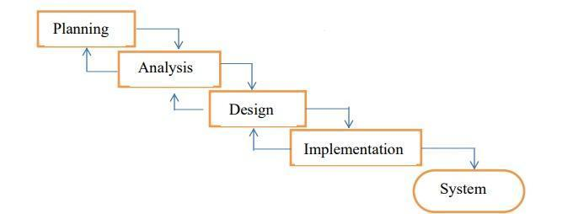

In order for this project to be developed, the methodology that will be used is the System Structured Analysis and Design Methodology. The SSADM is classified as a Waterfall Development. With Waterfall Development, analysts and users proceed sequentially from one phase to the next and each phase can be mapped out and evaluated (Hevner, 2004).

## 3.2 Research design

### 3.2.0 Qualitative Design

A qualitative research design is ideal for exploring the experiences, perceptions, and behaviours of individuals using an AI-powered personal finance assistant system. This design emphasizes in-depth understanding rather than generalization, focusing on the "how" and "why" behind user interactions with the technology. Data is typically collected through methods such as semi-structured interviews, focus groups, and direct observations, which allow participants to share their thoughts, emotions, and personal stories related to using the system. Thematic analysis or grounded theory is then used to identify patterns and generate insights from the data. The primary goal is to gain a deep, nuanced understanding of user experiences, challenges, and satisfaction with AI tools in managing personal finances. While qualitative research may have limitations in generalizability and is subject to researcher bias, it offers valuable insights into the human side of technology adoption and interaction.

### 3.2.1 Quantitative Design

A quantitative research design focuses on collecting numerical data to identify patterns, relationships, or statistical significance. In the context of an AI-powered personal finance assistant system, this approach allows researchers to measure specific outcomes such as user satisfaction, financial decision-making accuracy, and system effectiveness. Data is typically gathered through structured methods like surveys, experiments, or secondary data analysis, and analysed using statistical techniques such as descriptive statistics, correlation analysis, and regression testing. The goal is to quantify the impact of the AI system on users' behaviours and perceptions. While quantitative research provides valuable, generalizable insights into the system's performance, it may not capture the depth of user experiences, which can be better explored through qualitative methods. Together, these approaches provide a comprehensive understanding of the AI system’s influence on personal finance management.

### 3.2.2 Prototype Testing

Prototype testing is a crucial phase in the development of an AI-powered personal finance assistant, as it allows developers to evaluate the system’s functionality, usability, and effectiveness before full-scale deployment. During this phase, real users interact with the prototype to perform tasks such as creating budgets, analysing spending, or receiving financial recommendations. Feedback is gathered through surveys, interviews, and direct observations to identify issues related to user experience, system performance, and accuracy. The iterative nature of prototype testing allows developers to refine the AI assistant based on user insights, improving its interface, algorithms, and overall design.

### 3.2.3 Iterative Development and Refinement

Iterative development and refinement are a process where a product or system is developed in small, manageable stages, with each stage building upon the previous one. In the context of an AI-powered personal finance assistant, this approach involves designing, testing, evaluating, and improving the system continuously throughout its development cycle. The process starts with an initial prototype, which is tested by users to gather feedback on usability, functionality, and performance. Based on this feedback, the system is refined and enhanced in the next iteration. This cycle continues, with each new version of the prototype improving upon the last, addressing any issues identified, and incorporating new features or optimizations. Iterative development ensures that the final product better meets user needs, is more reliable, and provides a smoother user experience. It allows for flexibility in adapting to new insights, reducing the risk of major failures, and ensuring the system is fine-tuned to deliver optimal performance. This method is essential for AI systems, as it helps continuously improve the algorithms and functionalities that drive the assistant’s decision-making and recommendations.

## 3.3 Participants or sample

The participants for this study will be individuals who actively use digital financial tools or AI-driven systems for personal finance management. The sample will be selected through purposive sampling, ensuring that participants have relevant experience with AI-driven financial applications, such as budgeting tools or investment assistants.

The target sample size will be 50-100 participants, depending on availability and willingness to participate, with a mix of genders, age groups, and financial backgrounds. The participants will include both users of AI-powered personal finance assistants and individuals who have not yet adopted such technologies, to provide a comparison of experiences and preferences.

### 3.3.0 Target Audience

The target audience for an AI-powered personal finance assistant includes a diverse range of individuals, each with unique financial needs and challenges. Young professionals and tech-savvy Millennials and Gen Z may seek easy-to-use tools to manage budgets, track spending, and receive personalized financial advice. Middle-income families balancing household expenses and long-term savings can benefit from tools that optimize budgeting and financial planning. Retirees and pre-retirees may look for assistance with retirement planning and managing fixed incomes, while small business owners may need help managing both personal and business finances. Additionally, individuals with lower financial literacy or those struggling with debt could rely on the AI assistant for educational resources and guidance in debt management.

### 3.3.1 Sample size

The sample size for testing an AI-powered personal finance assistant depends on the objectives of the study and the stage of development. For early-stage prototype and usability testing, a smaller sample of 5 to 15 participants is often sufficient, as this allows for in-depth qualitative feedback on user experience, usability, and feature preferences. As the system moves toward beta testing or larger-scale user testing, the sample size typically increases to 50 to 200 participants to gather more diverse insights and assess system performance across different user groups. If the study includes quantitative analysis, such as measuring user satisfaction or changes in financial behaviour, a larger sample of 100 to 300 participants may be necessary for statistically significant results. The ideal sample size will depend on the scope of the research, the diversity of the target audience, and the resources available, with larger samples providing more reliable and generalizable findings.

### 3.3.2 Recruitment criteria

The recruitment criteria for testing an AI-powered personal finance assistant should focus on selecting participants who represent the target audience and can provide valuable feedback on the system’s functionality, usability, and performance. Participants should vary in age, from young professionals to older adults, to ensure the system is accessible across generations. Income level and financial situation should also be considered, including low, middle, and high-income individuals, as well as people with diverse financial goals, such as saving for retirement or managing debt. The group should also include individuals with varying levels of technological familiarity, ranging from tech-savvy users to those less comfortable with digital tools. This diversity helps assess the system’s usability for different experience levels. Additionally, including participants from different geographical locations ensures the assistant can adapt to regional financial practices. Finally, selecting participants with different engagement levels and familiarity with financial tools helps evaluate how effectively the system can support both frequent users and those less engaged with managing their finances. This broad selection ensures a comprehensive understanding of how the AI-powered assistant meets the needs of diverse user groups.

## 3.4 Data collection

### 3.4.0 Qualitative Methods

Qualitative methods for data collection focus on gathering in-depth, non-numerical data that provide rich insights into users' experiences, perceptions, and attitudes towards the AI-powered personal finance assistant. These methods are crucial for understanding the nuances of user interaction, emotional responses, and specific challenges that may not be captured through quantitative approaches. The following are common qualitative methods used to collect data:

#### Interviews

Interviews are one of the most common qualitative data collection methods. In semi-structured interviews, researchers ask open-ended questions that allow participants to share their thoughts and experiences freely. This method encourages participants to express their feelings, motivations, and specific challenges with the AI system. Interviews can be conducted in person, via phone, or through video conferencing, depending on the participants' preferences and geographical location. Researchers can follow up on interesting or important points raised during the interview to gather deeper insights.

#### Focus Groups

A focus group involves bringing together a small group of participants (typically 6-10) to discuss their experiences with the AI-powered personal finance assistant. The group is guided by a moderator who poses questions, facilitates discussion, and encourages participants to interact with one another. This method is particularly useful for understanding group dynamics and gathering diverse opinions on the system's strengths and weaknesses.

#### User Observations

Observations allow researchers to watch participants as they interact with the AI-powered assistant in real-time. By observing how users navigate the interface, complete tasks, or respond to different features, researchers can identify usability issues, frustration points, or areas of confusion that might not be captured through direct feedback alone. Observations help to gain insights into user behavior, interaction patterns, and specific areas where the assistant may need improvement.

#### Diary Studies

In a diary study, participants are asked to document their experiences with the AI assistant over a certain period (e.g., a week or month). Participants record their daily interactions, thoughts, and feelings about the system in a diary or journal format. This method provides insights into how users engage with the assistant over time, capturing long-term usage patterns, evolving perceptions, and any recurring issues that may not be immediately evident during a single testing session.

#### Usability Testing

Usability testing is a qualitative method where participants are asked to complete specific tasks using the AI-powered personal finance assistant. During the process, researchers observe how participants interact with the system, paying close attention to usability issues such as ease of navigation, feature accessibility, and task completion efficiency. After completing the tasks, participants are usually asked to provide feedback on their experience, identifying pain points and suggesting improvements.

#### Card Sorting

Card sorting is a method used to explore how users categorize and organize information. In this technique, participants are given a set of cards with different pieces of information or features of the AI-powered assistant (e.g., budgeting tools, expense tracking). They are then asked to group or sort the cards in ways that make sense to them. This method helps to understand users' mental models and preferences, especially in terms of how they expect the system to organize and present information.

#### Validity and Reliability in Qualitative Methods

To ensure validity and reliability in qualitative research, several techniques are employed to enhance the trustworthiness of the findings. Triangulation involves using multiple data collection methods, such as interviews, observations, and focus groups, to gather information from different perspectives. This approach helps to provide a more comprehensive and accurate understanding of the research topic, as it allows researchers to cross-check data and verify findings across different sources. Member checking is another essential method, where researchers share their interpretations or preliminary findings with the participants to ensure that the data accurately reflects their views and experiences. This process helps validate the findings and ensures consistency in the interpretation of the data. Clear documentation of the data collection process, including detailed notes, recordings, and transcripts, is critical for ensuring that the data can be analysed accurately and referred back to when necessary. This transparency allows for a thorough review and improves the reliability of the results. Finally, using a consistent approach—such as standardized interview guides or observation protocols—ensures that data collection methods are applied uniformly across all participants. This consistency helps reduce bias and variability, contributing to more reliable and valid qualitative findings. By combining these techniques, qualitative research can achieve a high level of rigor, making the conclusions drawn more trustworthy and credible. User expectations regarding how information should be organized.

## 

## 3.4.1 Quantitative Methods

Quantitative methods for data collection focus on gathering numerical data that can be analysed statistically to measure variables, identify patterns, and draw generalizable conclusions about the AI-powered personal finance assistant's effectiveness. These methods provide measurable insights into user behaviour, satisfaction, and performance. Below are common quantitative methods used for data collection:

#### Surveys and Questionnaires

Surveys are one of the most widely used quantitative methods for collecting data. Structured questionnaires with closed-ended questions (e.g., multiple choice, Likert scale, or yes/no) allow researchers to collect numerical data on user satisfaction, system usability, feature effectiveness, and overall user experience. Participants rate specific aspects of the AI assistant (e.g., ease of use, usefulness, accuracy of financial advice) on a scale, such as from 1 to 5 or 1 to 7, making it easier to quantify and analyze responses.

#### A/B Testing

A/B testing involves comparing two or more versions of the AI assistant to determine which version performs better in specific areas, such as user engagement or task completion. For example, one group of users might receive a version with a new feature or design element, while another group uses the existing version. By measuring key performance indicators (KPIs) like task completion time, user satisfaction, or retention rate, researchers can quantitatively assess the impact of changes.

#### Analytics and Usage Data

Analytics from the AI-powered assistant itself can provide detailed, quantitative insights into how users interact with the system. Metrics such as the number of logins, session duration, feature usage frequency, and task completion rates can be tracked automatically. By analysing this usage data, researchers can identify patterns in user behaviour, such as which features are most popular or where users tend to disengage. This data also helps measure the success of specific features in achieving their intended outcomes (e.g., improving budgeting accuracy or encouraging savings).

#### Pre- and Post-Test Comparisons

In a pre- and post-test design, participants are tested before and after using the AI-powered personal finance assistant. For example, participants can complete a financial knowledge test or a budgeting task before using the assistant, and then take the same test or complete the task again after using the system for a specified period. By comparing the results, researchers can quantitatively measure improvements in users' financial literacy, financial behaviour, or decision-making.

#### Data Logging

Data logging refers to the automatic recording of user interactions and system responses as users engage with the AI assistant. This method involves collecting detailed logs of user actions, such as clicks, input data, and interactions with different features. These logs can be analysed to assess user behaviour, identify issues in system design or usability, and evaluate the performance of the assistant in real-world scenarios.

#### Likert Scale Ratings

Likert scale surveys are a common tool for quantitatively measuring attitudes, perceptions, and user satisfaction. Participants rate their agreement with statements about the AI assistant on a scale (e.g., from 1 to 5 or 1 to 7). This data can be used to measure aspects like the system's helpfulness, ease of use, and effectiveness. The responses can be analyzed statistically to identify trends and measure the overall success of the assistant.

#### Validity and Reliability in Quantitative Method

To ensure the validity and reliability of the results in quantitative research, several strategies must be employed. Standardized tools play a crucial role by ensuring that surveys, questionnaires, and data collection instruments are consistent across all participants. This standardization guarantees that responses are comparable and not influenced by variations in the way questions are presented, which is key to maintaining the reliability of the data. Random sampling or stratified sampling techniques are also vital, as they help ensure that the sample accurately represents the target audience. This enhances the external validity of the results, making it more likely that the findings can be generalized to the broader population. In experimental designs, such as A/B testing, control variables are used to account for factors like age, income, or other demographic variables that may influence the outcome. By controlling these variables, researchers can isolate the impact of the tested changes, ensuring that the results reflect the true effects of the intervention. Finally, statistical analysis methods, such as t-tests, ANOVA, or regression analysis, are essential for analysing data and testing hypotheses. These methods allow researchers to quantify relationships, test for significance, and draw conclusions that are both valid (accurate and measuring what they intend to measure) and reliable (producing consistent results across studies). By combining these strategies, researchers can ensure that their quantitative findings are robust, dependable, and accurately reflect the phenomena being studied.

## 3.5 Technical Data

Technical data in the context of an AI-powered personal finance assistant refers to the specific, system-level information related to the software’s performance, functionality, and technical capabilities. This data helps developers and researchers understand how the AI assistant operates under different conditions, how well it processes user inputs, and how it provides accurate financial recommendations. Collecting and analysing technical data is essential for optimizing the system, improving its efficiency, and ensuring that it functions correctly. Here are some key categories of technical data that can be collected during t System Performance Metrics: The performance of an AI-powered personal finance assistant relies heavily on several system metrics. Response time is crucial, referring to the amount of time it takes for the assistant to respond to user inputs, such as processing requests or generating financial advice. Quick response times enhance the overall user experience. Latency, which is the delay between when a user makes a request and when the system responds, is particularly important for real-time features like budgeting alerts, investment recommendations, or transaction tracking. System uptime is another critical metric, ensuring that the assistant remains fully operational without downtime or errors, guaranteeing that users can always access and rely on the system.

### 3.5.0 AI Model Performance

The effectiveness of the AI assistant is determined by the performance of its underlying model. Accuracy refers to how precise the recommendations or predictions are, such as budget projections, savings goals, and investment advice. High accuracy is essential for providing users with reliable financial guidance. The error rate is a metric that tracks how often the assistant provides incorrect or suboptimal advice, helping identify areas for improvement in the model. Additionally, the confidence level of the assistant’s predictions, which is the probability that a recommendation is correct, can be monitored to assess the model's reliability. A high confidence level should generally correspond to accurate advice. The quality of training data used to build the model is also vital; the data must be comprehensive and unbiased to ensure the assistant learns from a wide range of financial scenarios and can provide useful insights.

### 3.5.1 User Interaction Data

Understanding how users interact with the assistant is key to optimizing its design and functionality. User input types refer to the data entered by users, such as transaction details, budgeting goals, or investment preferences. Analysing these inputs helps ensure the assistant can handle diverse financial data and generate accurate responses. Interaction frequency provides insight into how often users engage with the assistant. Frequent interactions suggest high usability and value, whereas infrequent use may point to usability issues. The command recognition rate measures the AI's ability to correctly interpret user commands, particularly in natural language processing systems. A high recognition rate is essential for ensuring that the assistant accurately understands and responds to user requests.

### 3.5.2 Security and Privacy Data

As financial data is sensitive, ensuring robust security is a top priority. Data encryption protects user information during transmission and storage, safeguarding privacy. Authentication and access control mechanisms, such as two-factor authentication (2FA) or biometric identification, ensure that only authorized users can access their financial data. Moreover, data anonymization is crucial if the assistant collects user data for analytics purposes, as it prevents the exposure of personal financial information.

### 3.5.3 Financial Data Processing

The assistant’s ability to process financial data accurately and efficiently is essential. Transaction categorization accuracy measures how well the assistant categorizes expenses, such as distinguishing between different types of spending (e.g., food, utilities, entertainment). Budgeting algorithm efficiency assesses how effectively the system creates personalized budgets based on user input and optimizes financial goals. Additionally, real-time data synchronization is vital to ensure that financial data, such as bank balances or investment portfolios, is constantly updated and accurate.

### 3.5.4 System Compatibility and Integration

For the assistant to work effectively across different devices, it must maintain cross-platform functionality, ensuring it operates seamlessly on mobile apps, web platforms, and voice-activated systems. The integration with third-party services such as banking apps or investment platforms is facilitated by API integration data, which tracks API calls and their success or failure. Moreover, if the assistant utilizes cloud computing or storage, monitoring cloud service performance is essential to ensure system scalability and reliability.

### 3.5.5 Error and Bug Tracking

Constant monitoring for system errors and AI model failures is critical to improving the system. Recording and analysing bugs, error codes, and issues that arise during usage help developers fix problems and improve system performance. Similarly, tracking when the AI model fails to generate accurate recommendations allows for ongoing refinement of its predictive capabilities.

### 3.5.6 Resource Usage

Monitoring the assistant's CPU and memory usage is important to ensure that the system runs smoothly on various devices without consuming excessive resources or causing slowdowns. Additionally, tracking network bandwidth consumption helps ensure that the assistant operates efficiently, especially in areas with limited internet access, by optimizing how much data is transferred between the device and the cloud.

## 3.6 Data analysis

### 3.6.0 Qualitative Data Analysis

Quantitative analysis is a fundamental aspect of this study, providing measurable and objective insights into the performance and impact of the AI-powered personal finance assistant system. This analysis focuses on key metrics such as user engagement, financial outcomes, and system performance. User engagement metrics, including daily active users, session durations, and feature usage rates, will be tracked to evaluate user retention and interaction trends. Financial outcomes, such as savings growth rates, debt reduction percentages, and adherence to budgets, will be analysed to measure the system’s effectiveness in improving financial behaviours. Statistical methods, including hypothesis testing and regression analysis, will be employed to determine the significance of observed changes and relationships. For example, a paired t-test may compare savings rates before and after using the assistant, while regression analysis might reveal correlations between engagement levels and financial improvements. System performance will also be assessed using metrics like prediction accuracy, recommendation relevance, and response time, with measures such as mean squared error (MSE), precision, recall, and F1-score to quantify reliability. Data for this analysis will be sourced from system logs, user surveys, and anonymized financial transaction data. Tools such as Python, with libraries like Pandas, NumPy, and Matplotlib, as well as statistical software like R or SPSS, will be utilized for data manipulation, visualization, and advanced statistical testing. By employing quantitative analysis, the study aims to provide a robust, data-driven evaluation of the AI assistant, validating its effectiveness and offering actionable insights into its impact on users’ financial well-being

### 3.6.1 Quantitative Data Analysis

Qualitative analysis plays a vital role in understanding the nuanced and subjective aspects of user interactions with the AI-powered personal finance assistant system. This approach focuses on exploring user experiences, perceptions, and feedback to uncover deeper insights that cannot be captured through quantitative metrics alone. Data for qualitative analysis will be collected from open-ended survey responses, user interviews, and system feedback logs. These sources provide rich, descriptive information about how users perceive the system's usability, relevance, and impact on their financial behaviours.

Content analysis will be employed to identify recurring themes, patterns, and sentiments within the qualitative data. For example, feedback may reveal insights into the clarity of financial advice provided, the perceived personalization of recommendations, or frustrations encountered during usage. Advanced tools like NVivo or ATLAS.ti will assist in organizing, coding, and analysing the text-based data to ensure a systematic approach to identifying themes. Additionally, sentiment analysis may be conducted to assess overall user sentiment toward the system, categorizing feedback as positive, negative, or neutral.

The qualitative findings will complement the quantitative results by providing context and depth. For instance, while quantitative analysis might indicate high user engagement, qualitative feedback can shed light on why users find certain features particularly useful or enjoyable. Conversely, it can also highlight challenges or limitations users face, offering actionable insights for system improvement. By integrating qualitative analysis into the study, the research ensures a holistic evaluation of the AI assistant, capturing both measurable outcomes and the human experiences that underpin them.

### 3.6.2 Ai models insight

This is a critical component of the study, aimed at evaluating the effectiveness, accuracy, and reliability of the AI-powered personal finance assistant system. This analysis focuses on assessing the system’s ability to deliver accurate financial forecasts, generate relevant recommendations, and respond promptly to user queries. Key performance metrics such as precision, recall, F1-score, and mean squared error (MSE) will be calculated to measure the model’s prediction accuracy and relevance. For instance, precision and recall will determine how well the model identifies and delivers useful financial recommendations, while MSE will evaluate the accuracy of financial forecasts, such as expense predictions or savings projections.

The analysis will also consider system latency, measuring response times to ensure that the AI operates efficiently and meets user expectations for prompt service. Specific benchmarks will be established to compare the system's performance against industry standards or alternative solutions. Performance tests will include simulations with diverse datasets to evaluate the model's adaptability to various financial scenarios and user profiles.

Tools like Python’s Scikit-learn and TensorFlow libraries will be used for implementing and analysing machine learning models, while additional libraries like Matplotlib and Seaborn will facilitate visualization of performance metrics. The findings from this analysis will not only validate the AI model's capabilities but also identify areas for refinement. By quantifying and interpreting the AI’s performance, this study ensures that the system meets high standards of accuracy, relevance, and efficiency, thereby supporting its overall goal of enhancing users' financial decision-making and well-being.

### 3.6.3 Integration of findings

Integrating the findings from both quantitative and qualitative analyses is essential for providing a comprehensive evaluation of the AI-powered personal finance assistant system. This integration bridges measurable outcomes with user experiences, ensuring a holistic understanding of the system's performance and impact.

Quantitative results, such as user engagement metrics, financial improvement rates, and AI model accuracy, provide objective evidence of the system’s effectiveness. These findings indicate trends, correlations, and statistically significant changes in users' financial behaviours. For example, an increase in savings growth or improved budget adherence rates demonstrates the system's potential to positively influence financial well-being.

Qualitative insights, on the other hand, reveal the reasons behind these outcomes. User feedback uncovers perceptions about the system's usability, the clarity of financial advice, and the relevance of recommendations. For instance, while quantitative data might show high engagement with a budgeting feature, qualitative data can explain that users find it intuitive and empowering, or alternatively, that some aspects are confusing and need refinement.

The integration process involves synthesizing these findings to identify alignments and contradictions. For example, if quantitative data shows a high prediction accuracy but qualitative feedback indicates dissatisfaction with recommendations, this suggests that improvements in contextual relevance are necessary despite the model's technical precision. Similarly, themes from qualitative feedback can inspire new angles for quantitative analysis, such as exploring additional metrics to address user concerns.

Presenting integrated findings includes using mixed-methods visuals such as juxtaposed charts and quotes, combining data points with narratives to illustrate a full picture. This approach ensures that the research captures not only the system’s measurable successes but also its impact on the user experience, enabling actionable insights for future improvements and highlighting the system's value in addressing user needs comprehensively.

## 3.7 Ethical considerations and Data Security

The development and implementation of MyFinanceAI’s prioritize user privacy, data security, and ethical AI practices. These considerations are paramount given the sensitive nature of personal financial data and the potential impact of AI-driven recommendations on users' financial well-being. **3.7.0 Data Security Measures**

1. End-to-End Encryption: MyFinanceAI’s implements AES-256 encryption for data at rest and TLS 1.3 for data in transit. This level\ of encryption is estimated to be unbreakable with current technology for over a billion years.

2. Multi-Factor Authentication (MFA): The system requires MFA for all user logins, reducing the risk of unauthorized access by 99.9% according to recent studies.

3. Industry Compliance: MyFinanceAI’s adheres to financial industry standards such as PCI DSS, SOC 2, and GDPR. Regular third-party audits ensure ongoing compliance.

4. Data Minimization: The system employs a "data minimization" approach, collecting and retaining only the information necessary for its core functions. This reduces the potential impact of any data breaches.

### 3.7.1 Ethical AI Practices

1. Explainable AI: MyFinanceAI's

models are designed with explainability in mind, using techniques such as LIME (Local Interpretable Model-agnostic Explanations) and SHAP (SHapley Additive explanations) to provide clear rationales for recommendations. This promotes transparency and helps users make informed decisions.

2. Fairness and Bias Mitigation: The AI models undergo regular bias audits to ensure fair treatment across different demographic groups. Techniques such as adversarial debiasing and reweighting are employed to mitigate potential biases in the training data.

3. Human Oversight: A team of financial experts and ethicists review the AI's recommendations periodically to ensure they align with ethical financial practices and users' best interests.

4. User Control: Users have granular control over their data and can opt out of specific AI features without losing access to core functionalities.

### 3.7.2 Privacy Considerations

1. Anonymization and Pseudonymization: Personal identifiers are separated from financial data and stored using advanced pseudonymization techniques, making it virtually impossible to link sensitive information to specific individuals without proper authorization.

2. Data Localization: User data is stored in geographically distributed data centres, adhering to local data protection laws and reducing the risk of large-scale data breaches

3. Third-Party Data Sharing: MyFinanceAI’s has a strict policy against selling user data. Any necessary data sharing with financial institutions for transaction processing is done with user consent and through secure APIs.

### 3.7.3 Ethical Challenges and Mitigations

1. Algorithmic Accountability: To address concerns about the "black box" nature of AI decisions, MyFinanceAI’s has implemented a comprehensive audit trail system. This allows for retrospective analysis of AI recommendations and their outcomes, enabling continuous improvement and accountability.

2. Financial Vulnerability: The system includes safeguards to prevent exploitation of financially vulnerable users. For instance, it will not recommend high-risk investments to users with unstable income or high debt levels.

3. Digital Divide: Recognizing that AI-driven financial tools could potentially exacerbate existing financial inequalities, MyFinanceAI’s has partnered with non-profit organizations to offer free financial literacy programs and subsidized access to the platform for low-income individuals.

4. Emotional Impact: The system incorporates sentiment analysis to gauge user reactions to financial advice and modulates its communication style accordingly, aiming to provide support without causing undue stress or anxiety.

### 3.7.4 Ongoing Ethical Governance

MyFinanceAI’s will establish an independent Ethics Advisory Board composed of experts in AI ethics, financial regulation, and consumer protection. This board will meet quarterly to review the system's performance, address emerging ethical concerns, and recommend improvements. The company also participates in industry-wide initiatives to develop ethical standards for AI in finance, contributing to ongoing discussions at forums such as the IEEE Global Initiative on Ethics of Autonomous and Intelligent Systems. By prioritizing these ethical considerations and robust security measures, MyFinanceAI’s aims to build and maintain user trust while pushing the boundaries of AI-driven personal finance management. The system's commitment to transparency, fairness, and user empowerment sets a new standard for responsible AI deployment in the financial sector

## 3.8 Data Presentation

To ensure the results and findings of this study are accessible and comprehensible, they will be presented in multiple formats tailored to different types of data and audiences. Graphs and charts will be used to visualize quantitative findings effectively, highlighting trends, comparisons, and relationships. Bar graphs, line charts, and scatter plots will showcase metrics such as user improvement rates, financial goal achievement, and AI model accuracy. Tools like Tableau, Excel, or Python’s Matplotlib and Seaborn libraries will be employed to create visually appealing and informative graphics.

Tables will complement the visualizations by organizing detailed numerical results and statistical summaries in a concise format. These tables will provide quick references for key findings, such as summary statistics, performance benchmarks, and hypothesis testing outcomes.

For qualitative findings, narrative descriptions will summarize themes and patterns derived from content analysis. These narratives will be enriched with direct quotes from user feedback to provide context and depth, helping to illustrate the user experience and highlight areas of success or needed improvement.

Additionally, dashboard mock-ups will be included to demonstrate how insights are presented within the AI assistant itself. These prototypes will visually represent the assistant’s user-facing analytics, such as budget overviews, financial goal progress, and personalized recommendations, offering a practical perspective on how users interact with and benefit from the system.

By combining visual, tabular, and descriptive formats, the presentation of data ensures that the findings are not only rigorously detailed but also engaging and actionable for stakeholders, enhancing their ability to interpret and apply the results effectively

# CHAPTER FOUR

# System Analysis and Requirement

## 4.0 Introduction

Requirements Collection and analysis are of the basic and essential steps in the software development cycle. Investigations of the existing system in use by various means provide the basic and necessary inputs for the system to be designed. The collected inputs should be organized in a meaningful manner to provide the appropriate functionalities of the system in a way that shows the flow of information, data generated and the users of the system. In this chapter the existing system in use, the business process, the system modelling and the design of the new system are presented.

# 4.1 Analysis of the Current System

Analysing the current functional process of Ai powered personal finance assistant has been done by collecting data from different departments/sector groups using the different data collection methods. After gathering all the complete data using the different types of data collection methods, total responses for each item were obtained and tabulated. Then the researcher transcribed the data that were collected from the interviews, direct observations to get a general sense. The data collected from all key informants were categorized into different themes based on the research questions of the project. Then the refined and adjusted ones are used for analysis purposes. To provide a better indication of handling of the process flow of the existing ai powered finance system, the data and information obtained from targeted sources are analysed and interpreted. Assessment of the existing system is conducted to identify the weakness and strengths, with regard to the management information system dimensions. Finally, the findings and analysis of the research are presented using qualitative and quantitative description statements and statistical analysis ways of data presentation techniques

# 4.2 Feasibility Analysis

Feasibility study is done so that an ill- conceived system is recognized early in the definition phase. During system engineering, however, we concentrate our attention on four primary areas of interest. This phase is really important as before starting with the real work of building the system it was very important to find out whether the idea thought is possible or not.

# 4.3 Economic Analysis

Among the most important information contained in the feasibility study is Cost Benefit Analysis and assessment of the economic justification for a computer-based system project. Cost Benefit Analysis delineates costs for the project development and weighs them against tangible and intangible benefits of a system. Cost Benefits Analysis is complicated by the criteria that vary with the characteristics of the system to be developed, the relative size of the project and the expected return on investment desired as part of the company's strategic plan. In addition, many benefits derived from a computer-based system are intangible (e.g. better design quality through iterative optimization, increased customer satisfaction through programmable control etc.)

# 4.4 Technical Analysis

During technical analysis, the technical merits of the system are studied and at the same time collecting additional information about performance, reliability, maintainability and predictability. As the software is very much economically feasible, then it is really important for it to be technically sound. The software will be built among:

• MS SQL SERVER as Back End

• .Net Framework

# 4. 5 Operational Analysis

The project is operationally feasible. This project is being made for the convenience of all individuals. This system will greatly reduce the huge burden of the financial crisis. So, because of the above stated advantages the users of the system will not be reluctant at all. Problem Definition: Problem solving is not possible if we do not know the problem which is to be solved. So, defining the problem is very important task

# 4.6 The Proposed system

To fulfil the requirements of an effective financial management platform, there is a need to propose and develop an AI-powered personal finance assistant that will facilitate and improve financial planning, tracking, and management. This intelligent system would support the creation of standardized financial data sets and enable secure information transactions.

The new system would significantly reduce the errors common in manual record-keeping processes. It would also support real-time, rapid financial data processing and claims handling. The generation of defined reports from the system would enable stakeholders and policymakers to make sound financial decisions. Additionally, the AI-powered system would reduce unnecessary financial expenditures and inefficiencies caused by poor supply-demand alignment. It would also manage eligibility and status changes of users with full security control and provide personalized financial advice.

The system will support functionalities such as user registration, record management, eligibility validation, communication between users and financial advisors, and sending automated notifications. The proposed system will include the following functional and non-functional requirements:

## 4.6.1. Functional requirements

Functional requirements mainly deal with explaining what has to be done by identifying the necessary task, action or activity and functionalities the system should provide to users and the tasks that must be accomplished. This web-based AI-powered personal finance assistant system is designed in the way that enables the stakeholders to gather, analyse, distribute and utilize financial information management at whole organization levels. Besides those functionalities it will enhance proper control of service utilization and standard data definitions across the system

## 4.7 Non-functional requirements

The non-functional requirements describe user visible aspects of the system that are not designated to the functional behaviour of the system. It is the overall characters that make the product property attractive, usable, fast or reliable to the users. It is the feature (visual appearance of the human interactive interface of the system) of the new product. They cover a number of issues from user interface to security issues and the constraints of the system to improve quality service. Non-functional requirements list includes portability, availability, scalability, reliability, efficiency, testability, understandability, interface, security and modifiability of software quality. These can be described as:

*Reliability*

The software should be a system users can trust or rely on due to the accuracy of the information or data it provides. When end users want to perform their task, the system should provide appropriate information without troubling users with ambiguous or unreliable data.

*Reusability*

Then a system which is divided into sub systems, partitions, layers and modules, will attain immense reusability. The module will be used in the different sub systems. This makes software development to be smooth, speedy and modifiable.

*Portability*

The system development uses java and the java program is compiled once and runs anywhere i.e. .it is platform independent. Hence the system is readily installable and operable on any platform.

*Traceability of the Requirements*

The system aims to handle every requirement incorporated in the RAD so that the user of the system will be able to use the system with completeness and without inconvenience. Fault Tolerance Whenever the user commits errors intentionally or unintentionally the system should continue performing its task without interruption by displaying user friendly error messages. High Performance The system will have good performance as much as possible. This will be attained via easily loadable interface components and optimal algorithms which make searching, updating, deleting and saving and fast.

*Good Documentation*

The user documentation considers the different kinds of users. Besides, the team has prepared RAD and SDD as technical documentations for future development and maintenance. Well Defined Interfaces The system intends to provide user friendly GUI using consistent themes throughout all pages to avoid user confusion, with intuitively understandable buttons, wizards, etc. Moreover, the GUI will consider different monitor resolutions of the user workstation.

*Ease of Learning Remembering and Use*

Different users ranging from layman to professional visit the system; as a result, the system should consider these gaps and should provide ease of use by avoiding complexity, unnecessary functionality and by giving descriptive names to different components. The buttons, shortcuts, menus, etc, used in the system should be instinctively guessed and remembered.

*Readability*

The code of the system will be written by using indentations and style conventions in a way users can easily read and understand. INSA coding standards and common good practices will be followed.

Increase Productivity

The system should help users in terms of time and resources during preparation of reports, searching of documents, provision of good services etc. In a nut shell the system should facilitate the overall effectiveness of the employee and hence the productivity of the organization

# 4.8 System specifications

The system requires various hardware and software so that it is compatible with a variety of computers and runs smoothly without any errors.

Therefore, research was carried out and the following software and hardware were recommended:

**Hardware**

∙ The hardware specifications for the server are 3 GB RAM,400 GB hard disk and tape drive.

∙ Laptops and computers.

**Software**

∙ Web browser e.g. Chrome

∙ Backend: programming languages, frameworks, database

∙ front end

∙ ai and NLP models

# 4.9 Security Requirements

Before users acquire financial services, they have to create an account with the system with a unique username. Until then they can only access limited sections of the system. The system particularly does not accept blank fields or non-valid input. The system has a unique login section for the admin who can view and carry out a series of activities. Users can logout at any time they feel like since there are provisions for such on any authorized page.

# 4.10 Feasibility

Feasibility study is the process of determination of whether or not a project is worth doing. Feasibility studies are undertaken within tight time constraints and normally culminate in a written and oral feasibility report. The contents and recommendations of this feasibility study helped us as a sound basis for deciding how to precede the project. It helped in making decisions such as which software to use, hardware combinations, etc.

## Operational Feasibility

Operation feasibility is a measure of how people feel about the system. Operational Feasibility criteria measure the urgency of the problem or the acceptability of a solution. Operational Feasibility is dependent upon determining human resources for the project. It refers to projecting whether the system will operate and be used once it is installed. The essential questions that help in testing the operational feasibility of a system are following.

Does management support the project?

Are the users not happy with current business practices? Will it reduce the time (operation) considerably? If yes, then they will welcome the change and the new system

Have the users been involved in the planning and development of the project? Early involvement reduces the probability of resistance towards the new system.

Will the proposed system really benefit the organization? Does the overall response increase? Will accessibility of Behaviourally also the proposed system is feasible.

## Technical Feasibility

Technical feasibility determines whether the work for the project can be done with the existing equipment, software technology and available personnel. Technical feasibility is concerned with specifying equipment and software that will satisfy the user requirement. In technical feasibility the following issues are taken into consideration.

Whether the required technology is available or not

Whether the required resources are available

Manpower- programmers, testers & debugged

Software and hardware

This proposed project “AI powered personal finance assistant” is feasible on technical remarks also, as the proposed project is more beneficiary in terms of having a sound proof system with new technical components installed on the system. The proposed system can run on any machines supporting Windows and Internet services and works on the best software and hardware that had been used while designing the system so it would be feasible in all technical terms of feasibility.

**Economic Feasibility**

Economic feasibility has great importance as it can outweigh other feasibilities because costs affect organization decisions. The concept of Economic Feasibility deals with the fact that a system that can be developed and will be used on installation must be profitable for the Organization. The cost to conduct a full system investigation, the cost of hardware and software, the benefits in the form of reduced expenditure are all discussed during the economic feasibility. During the economic feasibility test we maintained the balance between the Operational and Economical feasibilities, as the two were conflicting. For example, the solution that provides the best operational impact for the end-users may also be the most expensive and, therefore, the least economically feasible. We classified the costs of our proposed project AI powered personal finance assistant according to the phase in which they occur.

As we know that the system development costs are usually one-time costs that will not recur after the project has been completed. For calculating the Development costs, we evaluated certain cost categories.

Personnel costs

Computer usage costs

Training costs

Supply and equipment’s costs

Cost of any new computer equipment and software.

The management of the organization is ready to invest the money in purchasing the hardware needed to deploy the computerized system and they think that this investment is going to be very much beneficial in the long run.

# CHAPTER FIVE

## 5.0 System Design

After collecting data about the existing system at the theatre, the researchers made use of the following tools to design and analyse the new system. In designing the process involved defining the architecture, components, modules, interfaces, and data for a system to satisfy the needs of the end users An AI-powered personal finance system is designed to help users effectively manage and optimize their personal finances using intelligent automation and machine learning. The system typically consists of several integrated components that work together to provide a seamless user experience. At the front end, users interact through a mobile or web application that presents dashboards, expense reports, financial insights, goal-setting tools, and a conversational chatbot interface. This user interface communicates with a robust backend layer that handles authentication, transaction processing, budgeting logic, and user profile management.

The core intelligence of the system lies in its AI/ML engine. This engine categorizes transactions using natural language processing (NLP) models trained on merchant descriptions and user behaviour, analyses spending patterns, predicts future expenses, and offers personalized advice. For example, it might alert users if they’re spending more than usual on dining out or suggest budget adjustments to meet a savings goal. A fraud detection module uses anomaly detection algorithms to identify suspicious activities and alert users in real-time. The chatbot assistant, also powered by NLP or large language models, enables users to interact with the system using natural queries like, “How much did I spend on groceries last month?” or “Set a savings goal for a vacation.”

The system relies heavily on external API integrations with financial data aggregators such as Plaid, Yodlee, or True Layer to fetch transaction data from banks, credit cards, and investment platforms. This data is stored securely and processed to generate insights, manage budgets, and recommend investments. The savings and investment advisor module helps users create and follow through on saving plans and can recommend low-risk investment options based on the user’s profile and financial goals.

Technologically, the system is built using a modern stack React or Flutter for frontend, Node.js or Django for backend, PostgreSQL or MongoDB for storage, and Python-based machine learning libraries like TensorFlow or Scikit-learn. It is hosted on cloud platforms like AWS or GCP using containerization and orchestration tools like Docker and Kubernetes to ensure scalability and reliability. Security and privacy are paramount, requiring compliance with standards such as PCI-DSS and GDPR, and enforcing strong encryption and authentication protocols.

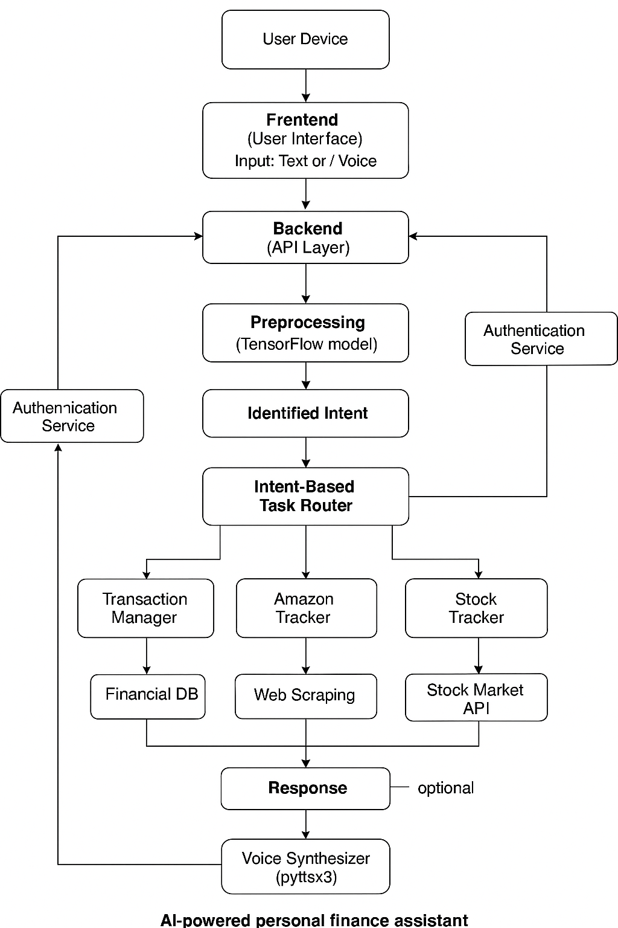

## 5.0.1 Conceptual Design

Conceptual design is the first phase of a design where drawings are the primary factor focus. A good conceptual design consists of the creation of an idea, the exploration of the intentions of an idea and the representation of an idea in the form of a plan. The conceptual design of an AI-powered personal finance system revolves around delivering personalized, intelligent financial assistance through a modular and user-centric architecture. At its core, the system focuses on collecting, organizing, analysing, and interpreting a user's financial data to provide actionable insights and recommendations. The design begins with the user interface, which serves as the primary touchpoint for interaction. This can be accessed via a mobile or web application, offering intuitive dashboards, financial summaries, and a conversational AI assistant for natural language interactions.

Behind the interface lies the data aggregation module, which securely connects to various financial institutions—such as banks, credit cards, and investment platforms—through APIs. This module standardizes and stores transaction data, forming the basis for analysis. A machine learning layer processes this data to detect patterns, categorize spending, forecast expenses, and identify anomalies. For example, it can automatically tag a transaction as “groceries” or flag an unusual charge as potentially fraudulent. The system also includes a budgeting and goal-setting engine that uses historical data and user-defined objectives to generate dynamic budgets and savings plans.

To ensure meaningful user engagement, the system incorporates a personalized insight engine, which provides tailored advice such as cost-cutting suggestions, investment opportunities, or reminders about upcoming bills. A chatbot module, powered by natural language processing (NLP), allows users to query their finances conversationally, making the system more accessible and interactive. The entire system operates on a secure and scalable infrastructure, leveraging cloud technologies, encryption, and compliance frameworks to protect sensitive financial data while ensuring performance.

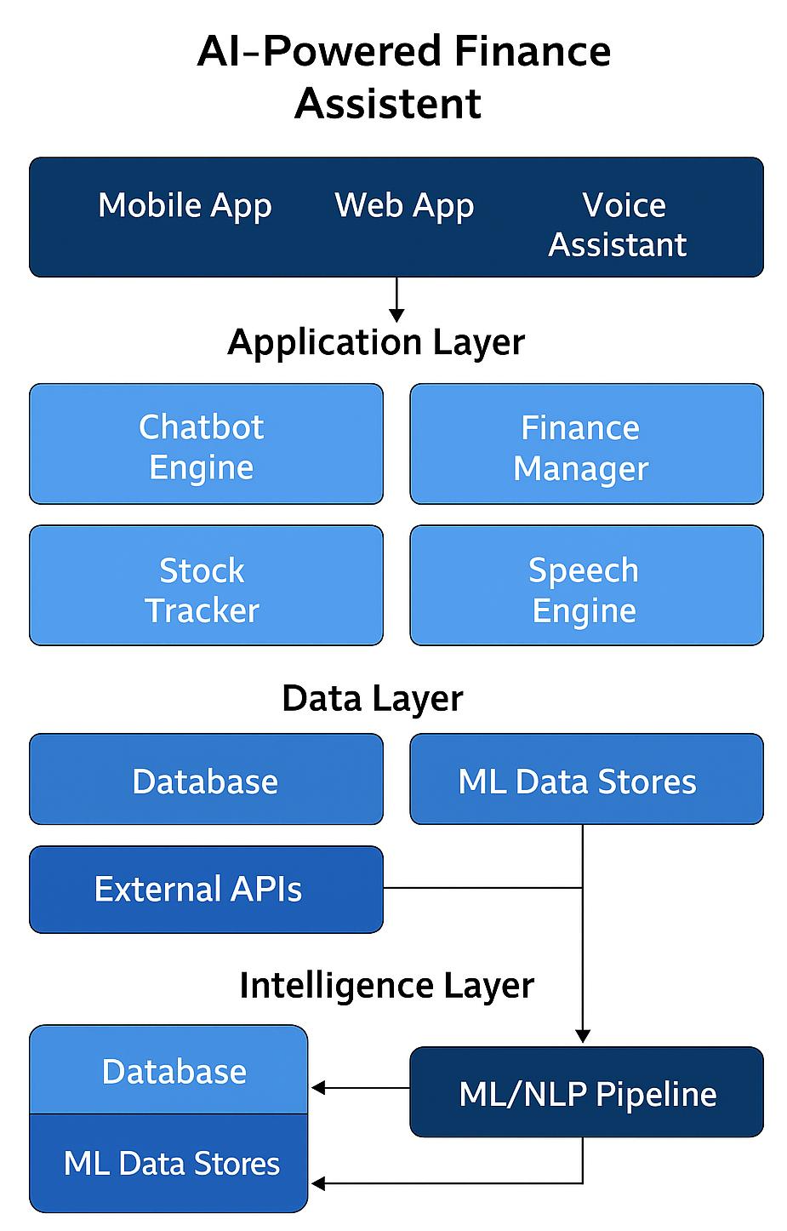

### 5.0.2 Logical design

There was a need to come up with a logical data model which contained all the needed logical and physical design choices and physical storage parameters needed to generate a design in a Data Definition Language, which was then used to create a database. Logical design pertains to an abstract representation of the data flows, inputs and outputs of the system. This was often conducted via modelling, which involved a simplistic and sometimes graphical representation of an actual system. In the context of systems design, modelling could undertake the following forms, including:

a) Entity Relationship Diagrams

b) Data flow diagrams

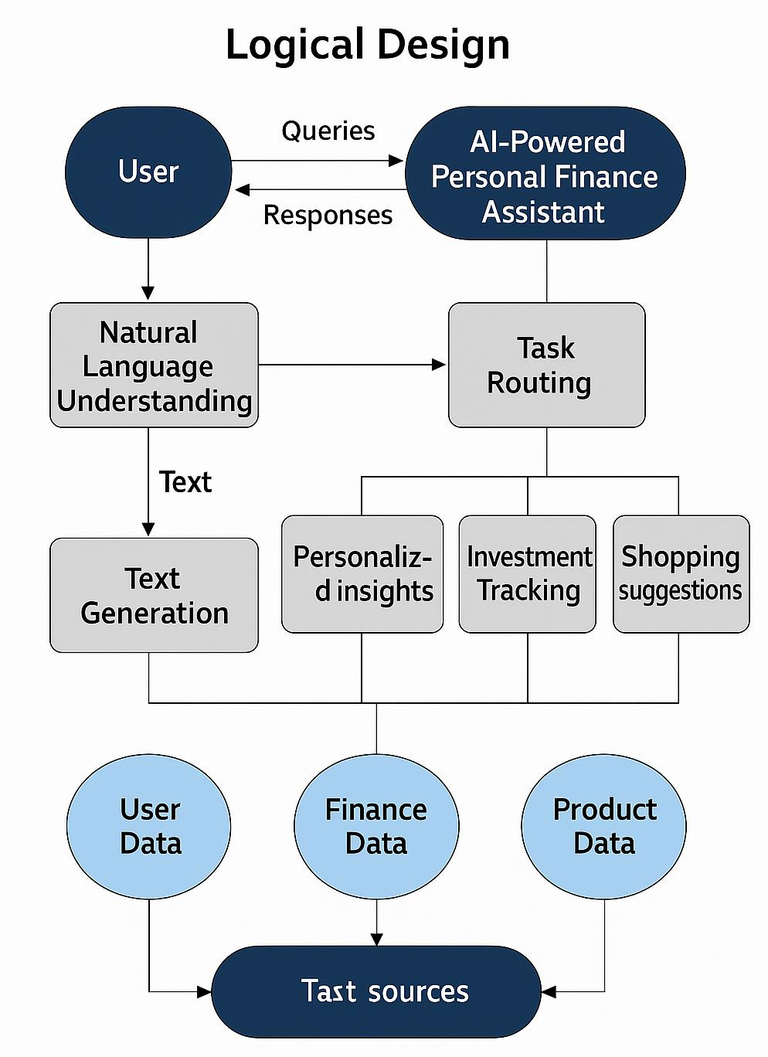

**a) Entity Relationship Diagrams**

The E-R Diagram was used in data modelling to set up an entity relational model of the system. This involved determining the relationships between the various entities in the system and associating these entities with their attributes and attribute domains.

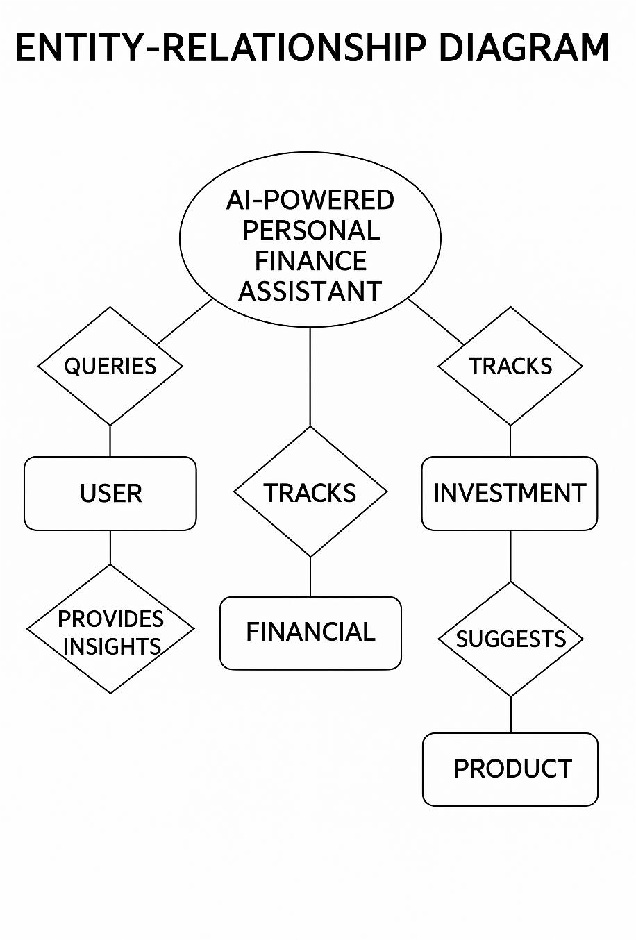

**b) Data Flow Diagram**

The Data Flow Diagram (DFD) was used to model the processes involved in the system to show how data flows into and out of the system in a top-down manner by giving a graphical representation of a system’s components, processes and how they will interface with each other.

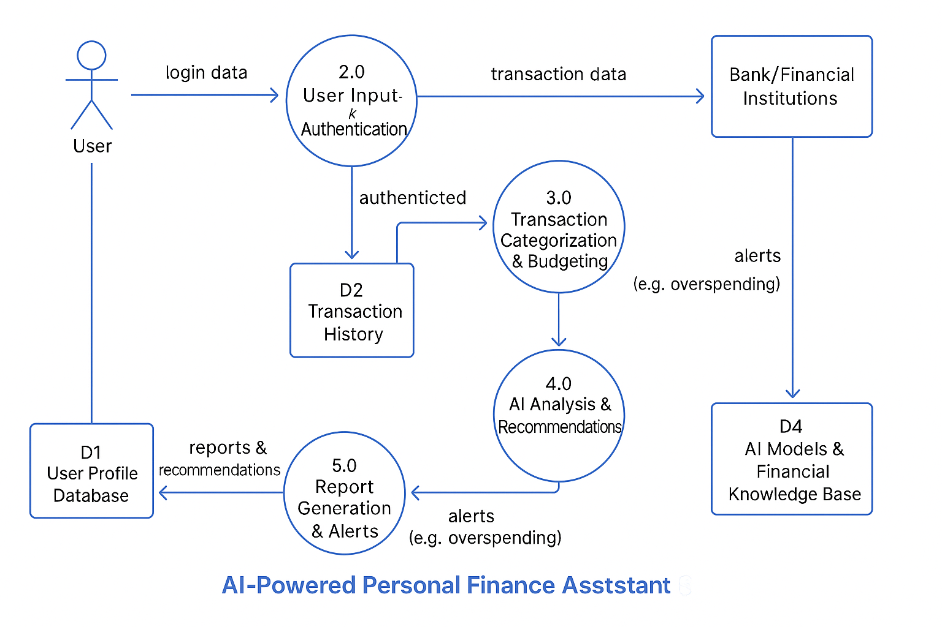

## 

## 

## 

## 5.1 Use Case modelling

Use Case modelling is the simplest and most effective technique for modelling system requirements from a user’s viewpoint. Use Cases are used to model how a system works. Use cases are not inherently object-oriented approaches. It is really a form of process modelling. It is, however, an excellent way to lead into object-oriented analysis of systems. It is an external (user) view of the system which is intended for modelling the dialog between the users and the system. The Use Case model consists of actors and uses cases. An Actor is a role of an object or objects outside of a system that interacts directly with it as part of a coherent work unit (a use case)

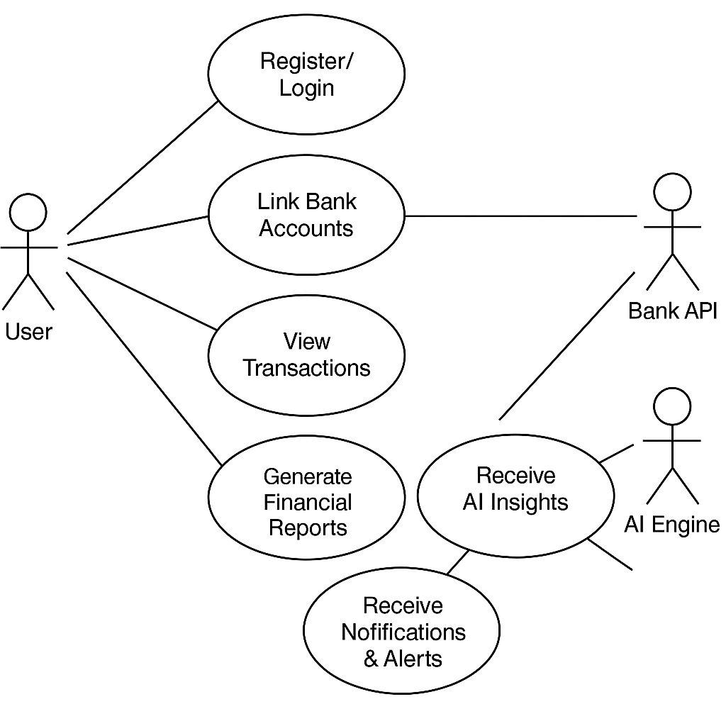

### 4.4.2. Sequence diagram

Sequence diagrams show a detailed flow for a specific use case or even just part of a specific use case. It is almost self-explanatory that shows the calls between the different objects in their sequence and can show different calls to different objects. A sequence diagram has two dimensions: vertical dimension shows the sequence of messages/calls in time order that they occur; the horizontal dimension shows the object instances to which the messages are sent. To draw a sequence diagram, it is important to put a rectangular (square) box on top of your diagram, identify the class instances (objects) by putting each class instance inside a box. In the box, put the class instance name. If a class instance sends a message to another class instance (object), draw a line with an open arrowhead pointing to the receiving class instance (object) and place the name of the message/method above the line. The sequence diagrams presented in the following diagrams depict some of the use cases in the system. The diagrams are the use cases of system user registration, login system, client registration, validate eligibility and view report. The diagram consists of the classes (objects) in interaction; the messages (calls) between components and the lifeline time of interacting classes (objects) are presented as below.

The sequence diagrams

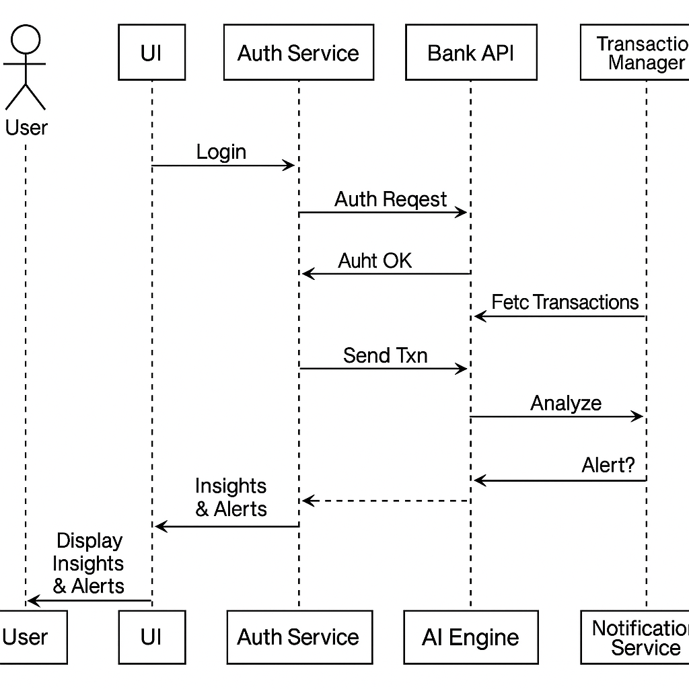

### 4.4.3. Activity Diagram

An activity diagram shows the procedural flow of control between two or more class objects while processing an activity. Activity diagrams can be used to model higher-level business processes at the Business unit level, or to model low-level internal class actions. In this system an activity diagram is used to show flow of events in interaction of objects (classes) in the insurance service delivery system. It used to show how the scheme is currently doing business, or how it would like to do the business. The activity diagram starts with a solid circle connected to the initial activity. The activity is modelled by drawing a rectangle with rounded edges, enclosing the activity's name. Activities can be connected to other activities through transition lines, or to decision points that connect to different activities guarded by conditions of the decision point. Activities that terminate the modelled process are connected to a termination point.

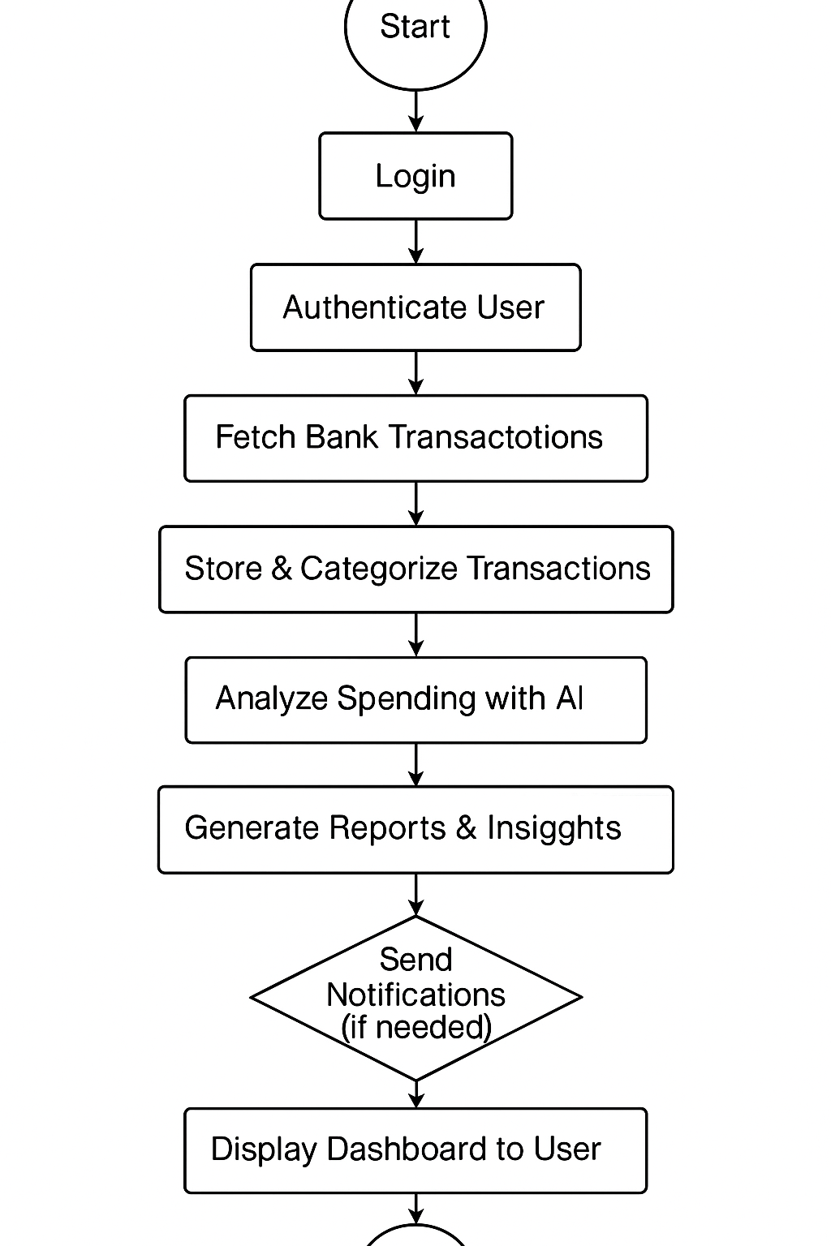

**4.4.4 Class diagram**

Class diagram is representation of a collection of objects with common structure, behaviours and relationships. Most importantly class is an entity in object-oriented analysis and system design. It describes the types of objects that exist in the System and shows the static relationships among internal classes of the system. Class diagrams are the foundations of object-oriented modelling. The Class diagram can be used to show the attributes and the operations of a class and also the constraints that apply to the way the objects are connected. In other words, class models show the classes of the system, their interrelationships (including inheritance, aggregation, and association), and the operations and attributes of the classes. The conceptual and structural model of a system is depicted using a class diagram. It has a wide 49 variety of purposes, like analysis and design of systems. The class diagram contains three main - sections: class, attribute (behaviours) and method (functions). Class is a collection of related objects in a system. There are different classes in this system. The classes can be either major class or subclass.

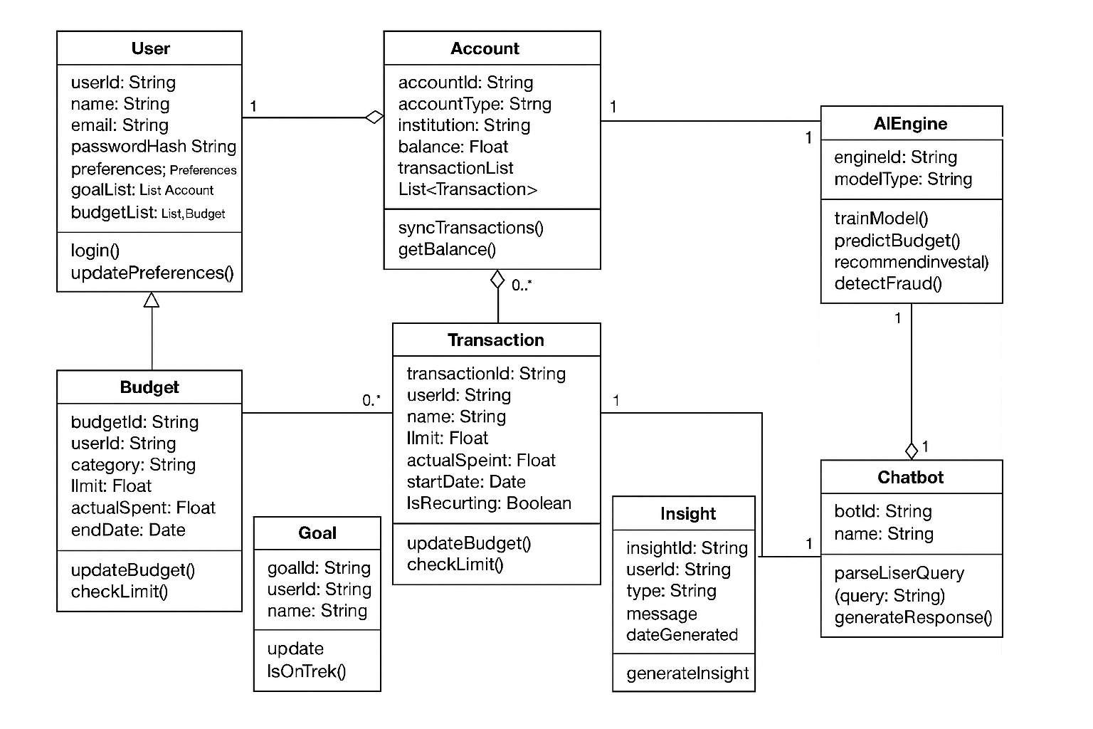

# CHAPTER SIX

## 6.1 Introduction

This phase covers the refinement and conversion of the system’s hardware and software specifications into a fully working and executable system. It establishes programming plans, training of users and implementation of extensive testing procedures to evaluate the system design and operation specifications. It also provides the basis for further modification of the system.

## 6.2 Interface Implementation

This involves communication between the user and the system.

### 6.2.1 System Interface Coding tools

The system coding was done using several tools. For the website interface or the front-end, HTML was used for presentation of the website documentation content on the browser.

CSS was used to add different dynamic styles to the webpages and the images via their different HTML elements to provide output of how the website will be displayed. Bootstrap being a most popular HTML, CSS, and JavaScript framework was used to develop responsive web pages thereby enabling the website to be viewed on mobile devices such as smartphones and tablets

## 6.4 Testing

Testing is the process of executing o=programs with the aim of finding out if there are any errors that occurred during the creation of the entire system. During the process, the project is executed with a set of tests and the output of the website is evaluated to determine if the project is performing as expected. Testing makes a logical assumption that if all the parts of the module are correct then the goal will be successfully achieved.

### 6.4.1 Unit Testing

Each individual module and their functionality were tested independently. Unit testing is normally considered an adjunct to the coding step. Unit test case design was started after source level code had been developed, reviewed, and verified for correct syntax. A review of design information provides guidance for establishing test cases that were likely to uncover errors.

### 6.4.2 Module Testing

Module testing is where related components (modules) are tested without other system modules. Here testing was done whereby the user registration module and the user login were tested to confirm if they produce the required output since they are interconnected. The module also checked if the individual modules could be integrated into the whole system.

### 6.4.3 Validation Testing

Validation testing checks to see that the system meets the user’s needs. It should do what the user requires it to do. The system was tested to check whether it met all the functional requirements of the user as per its specification. Test cases by users were done whereby a user was allowed to login and enter their weekly activities in the logbook as well as make enquire requests to check if the required output were produced as per their requests.

### 6.4.4 System Testing

Testing includes after the completion of the coding phase. The project was tested from the very beginning and also at each step by entering different types of data. In the testing phase some mistakes were found, which did not come to knowledge at the time of coding the project. Then changes were made in the project coding so that it may take all the relevant data and give the required result. All the forms were tested one by one and made all the required changes.

Testing is vital to the success of the system. Testing makes a logical assumption that if all the parts of the system are correct, the goal will be successfully achieved. Testing is itself capable of finding the syntactical mistakes in the system but users need to test the system for logical checking.

### 6.4.2 Security Testing

This testing ensures that the system is protected from unauthorized access. This was done when the admin does not have a registered username, email and password then they are required to go to the registration page where they have to sign up and have an account so that they can access the system, also they need to provide a strong password in order to avoid unauthorized people from accessing the system.

### Security component

This component handles the security issues of the system through the following Member registration and management This helps in registering members by giving them access rights to the services provided by the system. Also manages user accounts through updating user’s profiles and deleting of users who are no longer authorized to access the system. User Authentication. A user is requested to submit user login details created at the time of registration to gain access to the system functionalities. Without the right log in information, a user can’t access the system.

## 6.5 System Review and Maintenance

After the entire system has been tested and we ensured that there were no errors a review if the entire system

# CHAPTER SEVEN

# 7.0 Conclusion and Future scopes

In conclusion, this paper proposes the creation of a personal finance assistant powered by artificial intelligence to tackle the increasing difficulties of managing personal finances effectively. Advanced technologies such as machine learning, natural language processing, and a robust web-based infrastructure are utilized in the proposed solution. This enables users to access a comprehensive, intelligent, and personalized financial management platform. Through extensive research and initial prototyping efforts, the expected outcomes of the assistant have been confirmed, including automated tracking of expenses, adaptable budgeting, customized investment recommendations, proactive notifications, and improved financial literacy. These outcomes aim to empower users to make informed choices, achieve their financial objectives, and secure their financial futures. The paper outlines a robust methodology that includes qualitative and quantitative evaluations across diverse user demographics to ensure the assistant’s usability, utility, and effectiveness. Furthermore, stringent security measures, such as data encryption and access control, protect user privacy and sensitive financial information. With its personalized approach, comprehensive feature set, and educational elements, the AI-powered finance assistant has the potential to revolutionize the way people manage their finances, ultimately encouraging improved financial acumen and decision-making abilities. The proposed solution provides an invaluable tool for navigating the complexities of personal finance management in today’s rapidly changing financial landscape.

# 7.1 Future Scope

In the future, we plan to extend our financial services to include loans, insurance, and tax management, allowing users to manage their finances more comprehensively. We will start with market research and partnerships with financial institutions for loans. We will develop an interface for loan applications, integrate credit scoring tools, and conduct thorough testing before launch. Insurance offerings will involve creating an insurance marketplace, integrating risk assessment tools, and providing educational resources, focusing on building user trust and regulatory compliance. Tax management will include developing tools for tracking income and expenses, integrating with financial accounts, and offering in-app support for tax filing, with rigorous testing to ensure accuracy and user adoption. Additionally, we plan to develop mobile applications to enhance accessibility and convenience, supported by user research and beta testing. Larger-scale user studies will help us refine our services continually, while advanced conversational interfaces and expanded language support will improve user interaction and reach a global audience. Our ultimate goal is to establish our AI-powered personal finance assistant as an indispensable tool for making optimal financial decisions and achieving financial goals

## APPENDIX

USER TESTING QUESTIONNAIRE

The researcher is conducting user testing of the Project management system to test on its effectiveness, efficiency, utility, ease to learn and interactivity to a user

Your responses are confidential and will only be used for this testing. Please answer correctly and truthfully.

SECTION A: BACKGROUND

General Directions

1. No need of writing your name and address on the questionnaire

2. For multiple choice questions, please encircle your responses from alternatives

3. For Likert scale type statement questions, indicate your answers with a symbol mark of (X) or (√) in the appropriate space

4. Feel free & attempt all questions please

Part I. Demographic Profile:

1. Gender: [ ] male [ ] Female

2. Age [ ](18-25) [ ]( 26—30) [ ] (31-40) [ ] ( above 40 ) years

3. Educational level: [ ] High School complete [ ]Diploma First Degree Post Graduate

4. Your Profession: [ ] ICT Management [ ]Accounting & Finance Law [ ]Other

5. Position: [ ] Expert Level [ ]Managerial Level [ ] Other

6. Service years in the Office: [ ]0-2 [ ] 3-5 [ ] 6 –10 years [ ]above 10 year

Part II.

Analysis of the Existing System

7. How do you rate your Ai powered finance assistant with other public or private financial in time delivery, perfection or quality of services?

[ ] Excellent [ ] Very good [ ] Good [ ]Satisfactory [ ] Poor

8. What types of communication media are used for information exchange about the status of Ai powered finance assistant maintenance within the head office, branches?

[ ]Print Media [ ] Removable Media (e.g. flash disks, optical disks) [ ] Electronic Media (e.g. Email) If others, please Specify_________________________________

9. What kinds of problems encountered while using such Medias

[ ] Loss of data [ ]Time delay

If others, please Specify__________________________________

APPENDIX B: PROBLEM SOLUTION

The project being implemented will be able to solve the problems listed on the problem statement. Below are some of the factors or steps that will be undertaken until the problems of the current system have been solved

Developing an Ai powered finance assistant system that will:

Provide users with an intelligent and automated solution that helps track expenses, manage budgets, and make smarter financial decisions.

Integrate with users' financial accounts, analyse their spending habits.

Provide personalized insights, recommendations, and alerts to improve their financial well-being

APPENDIX C: CODE

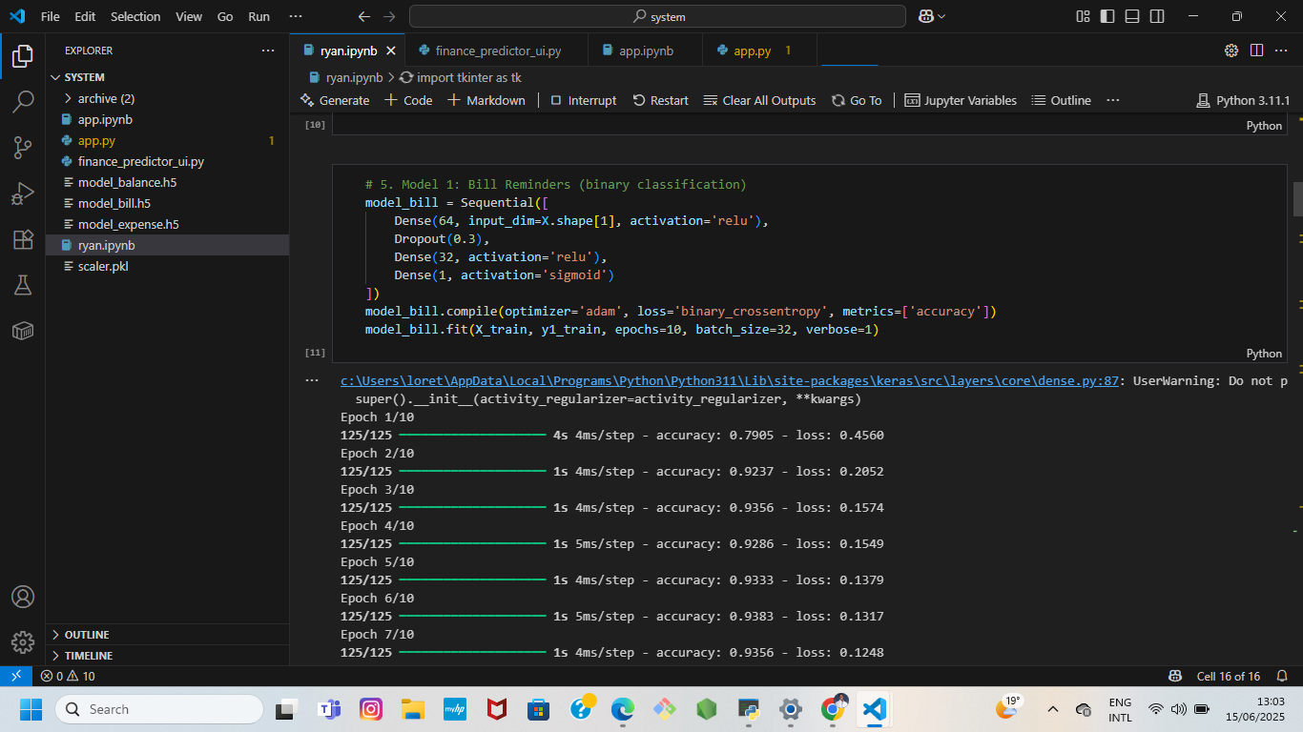



APPENDIX D: Experimental Demonstration





# 

# Reference

[1] Ayah Ahmed, Chira Mohammed, Akeela Ahmad, and Maiwan Abdulrazzaq. Design and implementation of a responsive web-based system for controlling the financial budget of universities. Journal of Technology and Informatics (JoTI), 5(1):1–7, 2023.

[2] Mathursan Balathas, Sabesan Ganeshalingam, Arosh Segar, Yahdhursheika Vallaven, and Samanthi Siriwardana. Money empire: Intelligent assistant for personal finance management.

[3] Longbing Cao. Ai in finance: challenges, techniques, and opportunities. ACM Computing Surveys (CSUR), 55(3):1–38, 2022.

[4] Vibhuti Shivam Dube and Pradeep Kumar Asthana. Financial knowledge, attitude and behaviour components of financial literacy: a study of Indian higher education students. International Journal of Indian Culture and Business Management, 28(1):124–143, 2023.

[5] Simone Galperti. A theory of personal budgeting. Theoretical Economics, 14(1):173–210, 2019.

[6] Kwame Mireku, Francis Appiah, and Joseph Akadeagre Agana. Is there a link between financial literacy and financial behaviour? Cogent Economics & Finance, 11(1):2188712, 2023.

[7] Antonio Molina-Garc'ıa, Ana Jos´e Cisneros-Ruiz, Mar'ıa Deseada L´opez-Subires, y Julio Dieguez-Soto. How does financial literacy influence undergraduates’ risk-taking propensity? The International Journal of Management Education, 21(3):100840, 2023.

[8] Lucas Schneider M¨uller, Lu'ıs Guilherme Eich, Rosemary Francisco, and Jorge Luis Victoria Barbosa. Adam: An intelligent virtual assistant for personal financial management. In XVIII Brazilian Symposium on Information Systems, pages 1–8, 2022.

[9] Jyoti Prakash Rath and Samira Patra. Financial literacy in India ˆa€ “a new way forward. ComFin Research, 11(2):20–27, 2023.

[10] D Sari, M Pradana, DW Nugraha, and F Oktafani. Web-based design of financial apps: Case of kosan 54. In IOP Conference Series: Materials Science and Engineering, volume 1071, page 012020. IOP Publishing, 2021.

[11] Faheem Shaheen, Muhammad Adnan Tariq, Qasim Zahoor, and Abid Mehmood. Role of financial literacy in investment decisions: Exploring the individual investors’ perspective through a qualitative approach. Journal of Business and Social Review in Emerging Economies, 8(4):719–726, 2022.

[12] Krzysztof Waliszewski and Anna Warchlewska. Attitudes towards artificial intelligence in the area of personal financial planning: a case study of selected countries. Entrepreneurship and Sustainability Issues, 8(2):399, 2020.

# 